

————————————————————————————————–

# Network Design and Programming Lab

### V Semester : B.Tech Computer Communication Engineering (CCE) Year : August 2024

—————————————————————————————————

#### DEPARTMENT OF INFORMATION AND COMMUNICATION TECHNOLOGY MANIPAL INSTITUTE OF TECHNOLOGY

**MANIPAL**

|  |  |  |
| --- | --- | --- |
| **1** | Course Objectives, Outcomes and Evaluation Plan | **1** |
| **2** | Instructions to Students | **2** |
| **3** | Lab No. 1: Introduction to Socket Programming |  |
| **4** | Lab No. 2: Chat Server using Socket Programming |  |
| **5** | Lab No. 3: Multiple Clients Communication using Socket Programming |  |
| **6** | Lab No. 4:  Implementation of Error Detection and Error Correction Techniques |  |
| **7** | Lab No. 5:  Congestion control using a Leaky bucket and Token bucket algorithm |  |
| **8** | Lab No. 6:  Implement Dijkstra’s algorithm and distance vector routing to compute the shortest path through a graph. |  |
| **9** | Lab No. 7: |  |
| **10** | Lab No. 8: Prototyping the Network Model using Packet Tracer |  |
| **11** | Lab No. 9: Basic Topologies using Packet Tracer |  |
| **12** | Lab No. 10: Routing Protocols using Packet Tracer |  |
| **13** | Lab No. 11: DHCP and NAT using Packet Tracer |  |
| **14** | Lab No. 12: Wireless Topology and VOIP using Packet Tracer |  |
| **15** | References |  |

# Plan

## Course Objectives

* + To learn client server socket programming.
  + To learn network concepts using packet tracer.

## Course Outcomes

* + Implement client server socket programming.
  + Simulate the network concepts using packet tracer.

## Evaluation Plan

* + Split up of 60 marks for Regular Lab Evaluation
    - Execution: 2 Marks
    - Record: 4 Marks
    - Evaluation: 4 Marks
  + End Semester Lab evaluation: 40 marks (Duration 2 hrs)
    - Program write-up: 20 Marks
    - Program execution: 20 Marks

## Pre-Lab Session Instructions

1. Students should carry the Lab Manual Book and the required stationery to every lab session
2. Be in time and follow the institution dress code
3. Must sign in the log register provided
4. Make sure to occupy the allotted seat and answer the attendance
5. Adhere to the rules and maintain the decorum

## In- Lab Session Instructions

1. Follow the instructions on the allotted exercises
2. Show the program and results to the instructors on completion of experiments
3. Prescribed textbooks and class notes can be kept ready for reference if required

## General Instructions for the exercises in Lab

* + Implement the given exercise individually and not in a group.
  + The programs should meet the following criteria:
    - Programs should be interactive with appropriate prompt messages, error messages if any, and descriptive messages for outputs.
    - Comments should be used to give the statement of the problem.
    - The statements within the program should be properly indented

*Instructions to Students*

* + Plagiarism (copying from others) is strictly prohibited and would invite severe penalty in evaluation.
  + In case a student misses a lab, he/ she must ensure that the experiment is completed before the next evaluation with the permission of the faculty concerned.
  + Students missing out the lab for genuine reasons like conference, sports or activities assigned by the Department or Institute will have to take prior permission from the HOD to attend additional lab (with another batch) and complete it before the student goes on leave. The student could be awarded marks for the write up for that day provided he submits it during the immediate next lab.
  + Students who feel sick should get permission from the HOD for evaluating the lab records. However, attendance will not be given for that lab.
  + Students will be evaluated only by the faculty with whom they are registered even though they carry out additional experiments in another batch.
  + The presence of the student during the lab end semester exams is mandatory even if the student assumes he has scored enough to pass the examination
  + Minimum attendance of 75
  + If the student loses his book, he/she will have to rewrite all the lab details in the lab record.
  + Questions for lab tests and examination are not necessarily limited to the questions in the manual, but may involve some variations and / or combinations of the questions.

## The students should NOT

* + Bring mobile phones or any other electronic gadgets to the lab.
  + Go out of the lab without permission.

# Lab No. 1: Introduction to Socket Programming

## Objectives

* + To illustrate the significance of socket programming
  + To recognize basic socket function calls by performing simple client server operations

## Introduction

Computer network is a communication network in which a collection of computers are connected together to facilitate data exchange. The connection between the computers can be wired or wireless. A computer network basically comprises of 5 components as shown in Figure.

* + Sender
  + Receiver
  + Message
  + Transmission medium
  + Protocols

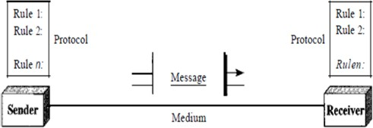

Components of data communication

## Client Server Architecture

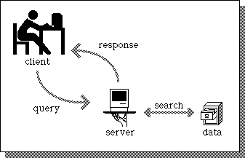Communication in computer networks follows a client server model as illustrated in Figure. Here, a machine (referred as client) makes a request to connect to another machine (called as server) for providing some service. The services running on the server run on known ports (application identifiers) and the client needs to know the address of the server machine and this port in order to connect to the server. On the other hand, the server does not need to know about the address or the port of the client at the time of connection initiation. The first packet which the client sends as a request to the server contains these information about the client which are further used by the server to send any information. Client (Active Open) acts as the active device which makes the first move to establish the connection whereas the server (Passive Open) passively waits for such requests from some client.

Illustration of Client Server Model

## Basics of Socket Programming

In UNIX, whenever there is a need for inter process communication within the same machine, we use mechanism like signals or pipes. Similarly, when we desire a communication between two applications possibly running on different machines, we need sockets. A network socket is an endpoint for sending or receiving data at a single node in a computer network that supports full duplex transmission.

Sockets are created and used with a set of programming requests or ”function calls”

sometimes called the sockets Application Programming Interface (API). The most common sockets API is the Berkeley UNIX C interface for sockets which are the interfaces between applications layer and the transport layer that acts as a virtual connection between two processes. Each socket is identified by an address so that processes can connect to them.

**Socket = IP Address + Port Number**

## Types of Communication Services

The data transfer between client and server application initiated by socket APIs can be achieved either by using connection oriented or connectionless services.

* + Connection Oriented Communication :In connection oriented service a connection has to be established between two devices before starting the communication to allocate the resources needed to aid the data transfer. Then the message transfer takes place until the connection is released. This type of communication is characterized by a high level of reliability in terms of the number and the sequence of bytes. It is analogous to the telephone network.
  + Connectionless Communication: In connectionless the data is transferred in one direction from source to destination without checking that destination is still there or not or if it prepared to accept the message. Authentication is not needed in this. It is analogous to the postal service where Packets (letters) are sent at a time to a particular destination.

Based on the two types of communication described above, two kinds of sockets are used:

* + Stream sockets: used for connection-oriented communication, when reliability in connection is desired. Protocol used is TCP (Transmission Control Protocol) for data transmission.
  + Datagram sockets: used for connectionless communication, when reliability is not as much as an issue compared to the cost of providing that reliability. For e.g.

Streaming audio/video is always sent over such sockets so as to diminish network traffic. Protocol used is UDP (User Datagram Protocol) for data transmission.

## Socket System Calls for Connection-Oriented Protocol

#### Steps followed by client to establish the connection:

1. Create a socket
2. Connect the socket to the address of the server
3. Send/Receive data
4. Close the socket connection

#### Steps followed by server to establish the connection:

1. Create a socket
2. Bind the socket to the port number known to all clients
3. Listen for the connection request
4. Accept connection request. This call typically blocks until a client connects with the server.
5. Send/Receive data
6. Close the socket connection

The sequence of socket function calls to be invoked for a connection oriented client server communication is depicted in Figure.

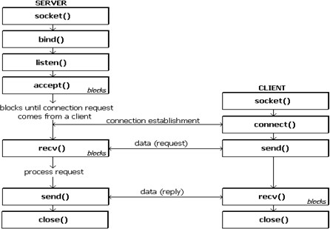

Connection oriented Socket Structure

The significance of these function calls is summarized.

* + Socket: Create a new communication request
  + Bind: Attach a local address to a socket
  + Listen: Announce willingness to accept connections
  + Accept: Block caller until a connection request arrives
  + Connect: Actively attempt to establish a connection
  + Send: Send some data over the connection
  + : Receive: Receive some data over the connection
  + : Close: Release the connection

## Socket System Calls for Connectionless Protocol

#### Steps of establishing a UDP socket communication on the client side are as follows:

1. Create a socket using the socket() function
2. Send and receive data by means of the recvfrom() and sendto() functions.

#### Steps of establishing a UDP socket communication on the server side are as follows:

1. Create a socket with the socket() function;
2. Bind the socket to an address using the bind() function;
3. Send and receive data by means of recvfrom() and sendto().

Figure shows the interaction between a UDP client and server. The client sends a datagram to the server using the sendto() function which requires the address of the destination as a parameter. Similarly, the server does not accept a connection from a client. Instead, the server calls the recvfrom() function, which waits until data arrives from some client. recvfrom() returns the IP address of the client, along with the datagram, so the server can send a response to the client.

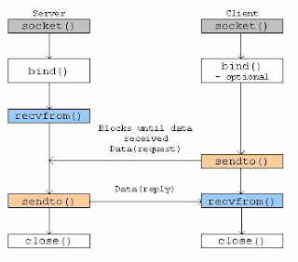

Connectionless Socket Structure

#### Socket System Calls in detail

* + Headers
  1. sys/types.h: Defines the data type of socket address structure in unsigned long.
  2. sys/socket.h: The socket functions can be defined as taking pointers to the generic socket address structure called sockaddr.
  3. netinet/in.h: Defines the IPv4 socket address structure commonly called Internet socket address structure called sockaddr in.
  + Structures: Various structures are used in Unix Socket Programming to hold information about the address and port, and other information. Most socket functions require a pointer to a socket address structure as an argument.

1. Sockaddr: This is a generic socket address structure, which will be passed in most of the socket function calls. It holds the socket information. The Table provides a description of the member fields.

s t r u c t s o c k a d d r {

u n s i g n e d s h o r t s a f a m i l y ; c h a r s a d a t a [ 1 4 ] ; } ;

Generic socket address structure fields

|  |  |  |
| --- | --- | --- |
| **Attribute** | **Values** | **Description** |
| **sa family** | **AF INET AF UNIX AF NS**  **AF IMPLINK** | **It represents an address family. In most of the Internet-based applications, we use AF INET.** |
| **sa data** | **Protocol-specific Address** | **The content of the 14 bytes of protocol specific address are interpreted according to the type of address. For the Internet family, we use port number IP address, which is represented by**  **sockaddr in structure.** |

1. sockaddr in: This helps to reference to the socket’s elements and Table provides a description of the member fields.

s t r u c t s o c k a d d r i n {

s h o r t i n t s i n f a m i l y ;

u n s i g n e d s h o r t i n t s i n p o r t ; s t r u c t i n a d d r s i n a d d r ;

u n s i g n e d c h a r s i n z e r o [ 8 ] ; } ;

Structure fields of sockaddr in

|  |  |  |
| --- | --- | --- |
| **Attribute** | **Values** | **Description** |
| **sa family** | **AF INET AF UNIX AF NS**  **AF IMPLINK** | **It represents an address family. In most of the Internet-based applications, we use AF INET.** |
| **sin port** | **Service Port** | **A 16-bit port number in Network Byte Order.** |
| **sin addr** | **IP Address** | **A 32-bit IP address in Network Byte Order.** |
| **sin zero** | **Not Used** | **This value could be set to NULL as this is not**  **being used.** |

1. in addr: This structure is used only in the above structure as a structure field and holds 32 bit netid/hostid. The Table provides a description of the member fields.

s t r u c t i n a d d r {

u n s i g n e d l on g s a d d r ; } ;

Structure fields of in addr

|  |  |  |
| --- | --- | --- |
| Attribute | Values | Description |
| s addr | service port | A 32-bit IP address in Network Byte Order. |

1. hostent: This structure is used to keep information related to host. The Table provides a description of the member fields.

s t r u c t h o s t e n t {

c h a r ∗ h name ;

c h a r ∗∗ h a l i a s e s ; i n t h a d d r t y p e ;

i n t h l e n g t h ;

c h a r ∗∗ h a d d r l i s t

# d e f i n e h a d d r h a d d r l i s t [ 0 ] } ;

Structure fields of hostent

|  |  |  |
| --- | --- | --- |
| Attribute | Values | Description |
| h name | ti.com etc. | It is the official name of the host. For example,  tutorialspoint.com, google.com, etc. |
| h aliases | TI | It holds a list of host name aliases. |
| h addrtype | AF INET | It contains the address family and in case of Internet  based application, it will always be AF INET. |
| h length | 4 | It holds the length of the IP address, which is 4 for  Internet Address. |
| h addr list | in addr | For Internet addresses, the array of pointers  h addr list[0], h addr list[1], and so on, are points to structure in addr. |

NOTE: h addr is defined as h addr list[0] to keep backward compatibility.

1. servent: This particular structure is used to keep information related to service and associated ports. The Table provides a description of the member fields.

s t r u c t s e r v e n t {

c h a r ∗ s name ;

c h a r ∗∗ s a l i a s e s ; i n t s p o r t ;

c h a r ∗ s p r o t o ;

} ;

Structure fields of servent

|  |  |  |
| --- | --- | --- |
| **Attribute** | **Values** | **Description** |
| **s name** | **http** | **This is the official name of the service. For**  **example, SMTP, FTP POP3, etc.** |
| **s aliases** | **ALIAS** | **It holds the list of service aliases. Most of the time**  **this will be set to NULL.** |
| **s port** | **80** | **It will have associated port number. For example,**  **for HTTP, this will be 80.** |
| **s proto** | **TCP**  **UDP** | **It is set to the protocol used. Internet services are**  **provided using either TCP or UDP.** |

* + Ports and Services:

To resolve the problem of identifying a particular server process running on a host, both TCP and UDP have defined a group of ports. A port is always associated with an

IP address of a host and the protocol type of the communication, and thus completes the destination or origination address of a communication session. A port is identified for each address and protocol by a 16-bit number, commonly known as the port number. Specific port numbers are often used to identify specific services as listed below.

1. Ports 0-1023 (well-known ports): reserved for privileged services like for ftp: 21 and for telnet: 23.
2. Ports 1024-49151 (registered ports): vendors use for some applications.
3. Ports above 49151 (dynamic/ephemeral/private ports): short-lived transport protocol port for Internet Protocol (IP) communications allocated automatically from a predefined range by the IP stack software. After communication is terminated, the port becomes available for use in another session. However, it is usually reused only after the entire port range is used up.
   * Constructing Messages - Byte Ordering: In computers, addresses and port numbers are stored as integers of type:
     + u short sin port; (16 bit)
     + in addr sin addr; (32 bit)

Unfortunately, not all computers store the bytes that comprise a multibyte value in the same order. There are 2 types of byte ordering.

* + - Little Endian (Host byte order)- in this scheme, low-order byte is stored on the starting address (A) and high-order byte is stored on the next higher address (A

+ 1).

* + - Big Endian (Network byte order)- in this scheme, high-order byte is stored on the starting address (A) and low-order byte is stored on the next higher address (A + 1).

Byte order conversion function description

|  |  |
| --- | --- |
| **Function** | **Description** |
| **htons()** | **Host to Network Short**  **(16 bit)** |
| **htonl()** | **Host to Network Long**  **(32 bit)** |
| **ntohl()** | **Network to Host Long**  **(32 bit)** |
| **ntohs()** | **Network to Host Short**  **(16 bit)** |

To allow machines with different byte order conventions communicate with each other, the internet protocols specify a canonical byte order convention for data transmitted over the network. This is known as Network Byte Order. Table describes some of the byte order functions available in UNIX programming.

* + IP Address Functions: These functions convert Internet addresses between ASCII strings (what humans prefer to use) and network byte ordered binary values (values that are stored in socket address structures). Some of the commonly used IP address functions are described below.

1. int inet aton(const char *strptr, struct in addr *addrptr): This function call converts the specified string in the Internet standard dot notation to a network address, and stores the address in the structure provided. The converted address will be in Network Byte Order (bytes ordered from left to right). It returns 1 if the string was valid and 0 on error.

Following is the usage example:

# i n c l u d e *<*a r p a / i n e t . h*>* ( . . . )

i n t r e t v a l ;

s t r u c t i n a d d r a d d r p t r

memset(& a d d r p t r , ’\ 0 ’ , s i z e o f ( a d d r p t r ) ) ;

r e t v a l = i n e t a t o n ( ” 6 8 . 1 7 8 . 1 5 7 . 1 3 2 ” , &a d d r p t r ) ; ( . . . )

1. in addr tinet addr(const char *strptr): This function call converts the specified string in the Internet standard dot notation to an integer value suitable for use as an Internet address. The converted address will be in Network Byte Order (bytes ordered from left to right). It returns a 32-bit binary network byte ordered IPv4 address and INADDR NONE on error.

Following is the usage example:

# i n c l u d e *<*a r p a / i n e t . h*>* ( . . . )

s t r u c t s o c k a d d r i n d e s t ;

memset(& d e s t , ’\ 0 ’ , s i z e o f ( d e s t ) ) ;

d e s t . s i n a d d r . s a d d r = i n e t a d d r ( ” 6 8 . 1 7 8 . 1 5 7 . 1 3 2 ” ) ; ( . . . )

1. char *inet ntoa(struct in addr inaddr): This function call converts the specified Internet host address to a string in the Internet standard dot notation. Following is the usage example:

# i n c l u d e *<*a r p a / i n e t . h*>* c h a r ∗ i p ;

i p = i n e t n t o a ( d e s t . s i n a d d r ) ;

p r i n t f ( ” IP Address i s : %s \ n ” , i p ) ;

## Programming Functions

1. Socket function: int socket (int family, int type, int protocol); This call returns a socket descriptor that you can use in later system calls or -1 on error.

Parameters:

* + family: specifies the protocol family and is one of the constants as given n Table.
  + type: It specifies the kind of socket you want. The possible socket types are

listed in Table.

Different socket address family

|  |  |
| --- | --- |
| **Family** | **Description** |
| **AF INET** | **IPv4 protocols** |
| **AF INET6** | **IPv6 protocols** |
| **AF LOCAL** | **Unix domain protocols** |
| **AF ROUTE** | **Routing Sockets** |
| **AF KEY** | **Ket socket** |

Socket Types

|  |  |
| --- | --- |
| **Type** | **Description** |
| **SOCK STREAM** | **Stream socket** |
| **SOCK DGRAM** | **Datagram socket** |
| **SOCK SEQPACKET** | **Sequenced packet socket** |
| **SOCK RAW** | **Raw socket** |

* + protocol: The argument should be set to the specific protocol type given below, or 0 to select the system’s default for the given combination of family and type

.The default protocol for SOCK STREAM with AF INET family is TCP. Other protocol description is given in Table.

Different protocols

|  |  |
| --- | --- |
| **Protocol** | **Description** |
| **IPPROTO TCP** | **TCP transport protocol** |
| **IPPROTO UDP** | **UDP transport protocol** |
| **IPPROTO SCTP** | **SCTP transport protocol** |

* + Example:

i f ( ( sd = s o c k e t ( AF INET , SOCK STREAM, 0 ) ) *<* 0 ) {

c o u t *<<*” S o c k e t c r e a t i o n e r r o r ” ; e x i t ( − 1 ) ;

}

1. Connect: The connect function is used by a TCP client to establish a connection with a TCP server. This call normally blocks until either the connection is established or is rejected.

int connect(int sockfd, struct sockaddr *serv addr, int addrlen);

This call returns 0 if it successfully connects to the server, otherwise it returns -1 on error.

Parameters:

* + sockfd: it is a socket descriptor returned by the socket function.
  + serv addr: it is a pointer to struct sockaddr that contains destination (Server) IP address and port.
  + addrlen: the length of the address structure pointed to by servaddr. Set it to sizeof(structsockaddr).

1. Bind: The bind function assigns a local protocol address to a socket. With the Internet protocols, the protocol address is the combination of either a 32-bit IPv4 address or a 128-bit IPv6 address, along with a 16-bit TCP or UDP port number. This function is called by TCP server only. bind() allows to specify the IP address, the port, both or neither. The Table summarizes the combinations for IPv4.

int bind(int sockfd, const struct sockaddr *servaddr, socklen t addrlen);

This call returns 0 if it successfully binds to the address, otherwise it returns -1 on error.

Parameters:

* + sockfd: it is a socket descriptor returned by the socket function.
  + servaddr: it is a pointer to struct sockaddr that contains the local IP address and port.
  + addrlen: Set it to sizeof(structsockaddr).

The ¡sys/socket.h¿ header shall define the type socklen t, which is an integer type of width of at least 32 bits.

1. Listen: The listen function is called only by a TCP server. It converts an unconnected socket into a passive socket, indicating that the kernel should accept incoming connection requests directed to this socket.

IP address and port number combinations

|  |  |  |
| --- | --- | --- |
| **IP Address** | **IP Port** | **Result** |
| **INADDR ANY** | **0** | **Kernel chooses IP address and port** |
| **INADDR ANY** | **non zero** | **Kernel chooses IP address, process specifies port** |
| **Local IP address** | **0** | **Process specifies IP address, kernel chooses port** |
| **Local IP address** | **non zero** | **Process specifies IP address and port** |

int listen(int sockfd,int backlog);

This call returns 0 on success, otherwise it returns -1 on error. Parameters:

* + sockfd: it is a socket descriptor returned by the socket function.
  + backlog: it is the maximum number of connections the kernel should queue for this socket.

1. Accept: The accept function is called by a TCP server to return the next completed connection from the front of the completed connection queue.

int accept (int sockfd, struct sockaddr *cliaddr, socklen t *addrlen);

This call returns a non-negative descriptor on success, otherwise it returns -1 on error. The returned descriptor is assumed to be a client socket descriptor and all read-write operations will be done on this descriptor to communicate with the client.

Parameters:

* + sockfd: It is a socket descriptor returned by the socket function.
  + cliaddr: It is a pointer to structsockaddr that contains client IP address and port.
  + addrlen: Set it to sizeof(structsockaddr).

1. Send: The send function is used to send data over stream sockets or CONNECTED datagram sockets. If you want to send data over UNCONNECTED datagram sockets, you must use sendto() function.

int send(int sockfd, const void *msg, int len, int flags);

This call returns the number of bytes sent out, otherwise it will return -1 on error. Parameters:

* + sockfd: it is a socket descriptor returned by the socket function.
  + msg: it is a pointer to the data you want to send.
  + len: it is the length of the data you want to send (in bytes).
  + flags: it is set to 0.The additional argument flags is used to specify how we want the data to be transmitted.

1. Recv: The recv function is used to receive data over stream sockets or CONNECTED datagram sockets. If you want to receive data over UNCONNECTED datagram sockets you must use recvfrom().

int recv(int sockfd, void *buf, int len, unsigned int flags);

This call returns the number of bytes read into the buffer, otherwise it will return -1 on error.

Parameters:

* + sockfd: it is a socket descriptor returned by the socket function.
  + buf: it is the buffer to read the information into.
  + len: it is the maximum length of the buffer.
  + flags: it is set to 0. The additional argument flags is used to specify how we want the data to be transmitted.

1. Sendto: The sendto function is used to send data over UNCONNECTED datagram sockets. Upon successful completion, sendto() shall return the number of bytes sent. Otherwise, -1 shall be returned and errno set to indicate the error.

int sendto(int sockfd, const void *msg, int len, unsigned int flags, const struct sockaddr *to, int tolen);

Parameters:

* + sockfd: it is a socket descriptor returned by the socket function.
  + msg: it is a pointer to the data you want to send.
  + len: it is the length of the data you want to send (in bytes).
  + flags: it is set to 0.
  + to: it is a pointer to struct sockaddr for the host where data has to be sent.
  + tolen: it is set it to sizeof(struct sockaddr).

1. Recvfrom: The recvfrom function is used to receive data from UNCONNECTED datagram sockets. Upon successful completion, recvfrom() shall return the length of the message in bytes. If no messages are available to be received and the peer has performed an orderly shutdown, recvfrom() shall return 0. Otherwise, the function shall return -1 and set errno to indicate the error.

size t recvfrom(int sockfd, void *buf, int len, unsigned int flags, struct sockaddr

*from, int *fromlen);

Parameters:

* + sockfd: it is a socket descriptor returned by the socket function.
  + buf: it is the buffer to read the information into.
  + len: it is the maximum length of the buffer.
  + flags: it is set to 0.
  + from: it is a pointer to structsockaddr for the host where data has to be read.
  + fromlen: it is set it to sizeof(structsockaddr).
  + ssize t: this data type is used to represent the sizes of blocks that can be read or written in a single operation. It is similar to size t, but must be a signed type.

1. Close: The close function is used to close the communication between the client and the server.

int close(int sockfd );

This call returns 0 on success, otherwise it returns -1 on error. Parameters:

* + sockfd: it is a socket descriptor returned by the socket function.

1. Shutdown: The shutdown function is used to gracefully close the communication between the client and the server. This function gives more control in comparison to

the close function.

int shutdown(int sockfd, int how);

This call returns 0 on success, otherwise it returns -1 on error. Parameters:

* + sockfd: it is a socket descriptor returned by the socket function.
  + how: Put one of the numbers:
    - 0 : indicates that receiving is not allowed,
    - 1 : indicates that sending is not allowed, and
    - 2 : indicates that both sending and receiving are not allowed. When ‘how’ is set to 2, it’s the same thing as close().

#### Sample exercise

Algorithm to implement an UDP Echo Client/Server Communication

#### Server:

1. Include the necessary header files.
2. Create a socket using socket function with family AF INET, type as SOCK DGRAM.
3. Assign the sin family to AF INET, sin addr to INADDR ANY, sin port to SERVER PORT.
4. Bind the local host address to socket using the bind function.
5. Within an infinite loop, receive message from the client using recvfrom function, print it on the console and send (echo) the message back to the client using sendto function.

#### Client:

1. Include the necessary header files.
2. Create a socket using socket function with family AF INET, type as SOCK DGRAM.
3. Initialize the socket parameters. Assign the sin family to AF INET, sin addr to “127.0.0.1”, sin port to dynamically assigned port number.
4. Within an infinite loop, read message from the console and send the message to the server using the sendto function.
5. Receive the echo message using the recvfrom function and print it on the console.

A simple UPD client-server program where a client connects to the server. Server sends a message to the client which is displayed at the client side.

#### Server Code

# i n c l u d e *<* s t r i n g . h*>* # i n c l u d e *<*u n i s t d . h*>*

# i n c l u d e *<*s y s / s o c k e t . h*>* # i n c l u d e *<*s y s / t y p e s . h*>* # i n c l u d e *<* n e t i n e t / i n . h*>* # i n c l u d e *<* s t d l i b . h*>*

# i n c l u d e *<* s t d i o . h*>* main ( )

{

i n t s , r , recb , sntb , x ; i n t ca ;

p r i n t f ( ” INPUT p o r t number : ” ) ; s c a n f (”% d ” , &x ) ;

s o c k l e n t l e n ;

s t r u c t s o c k a d d r i n s e r v e r , c l i e n t ; c h a r b u f f [ 5 0 ] ;

s= s o c k e t ( AF INET , SOCK DGRAM, 0 ) ;

i f ( s ==−1)

{

p r i n t f ( ” \ n Socket c r e a t i o n e r r o r . ” ) ;

e x i t ( 0 ) ;

}

p r i n t f ( ” \ n Socket c r e a t e d . ” ) ; s e r v e r . s i n f a m i l y =AF INET ;

s e r v e r . s i n p o r t = h t o n s ( x ) ;

s e r v e r . s i n a d d r . s a d d r = h t o n l ( INADDR ANY ) ; l e n = s i z e o f ( c l i e n t ) ;

ca= s i z e o f ( c l i e n t ) ;

r = b i nd ( s , ( s t r u c t s o c k a d d r ∗)& s e r v e r , s i z e o f ( s e r v e r ) ) ; i f ( r ==−1)

{

p r i n t f ( ” \ n Binding e r r o r . ” ) ; e x i t ( 0 ) ;

}

p r i n t f ( ” \ n Socket b i n d e d . ” ) ; w h i l e ( 1 ) {

r e c b = r e c v f r o m ( s , buff , s i z e o f ( b u f f ) , 0 , ( s t r u c t s o c k a d d r ∗)& c l i e n t ,& ca ) ; i f ( r e c b ==−1)

{

p r i n t f ( ” \ n Message R e c i e v i n g F a i l e d ” ) ; c l o s e ( s ) ;

e x i t ( 0 ) ;

}

p r i n t f ( ” \ n Message Recieved : ” ) ; p r i n t f (”% s ” , b u f f ) ;

i f ( ! s t r c m p ( buff , ” s t o p ” ) ) b r e a k ;

p r i n t f ( ” \ n\ n ” ) ;

p r i n t f ( ” Type Message : ” ) ;

s c a n f (”% s ” , b u f f ) ;

s n t b = s e n d t o ( s , buff , s i z e o f ( b u f f ) , 0 , ( s t r u c t s o c k a d d r ∗)& c l i e n t , l e n ) ; i f ( s n t b ==−1)

{

p r i n t f ( ” \ n Message Sending F a i l e d ” ) ; c l o s e ( s ) ;

e x i t ( 0 ) ;

}

i f ( ! s t r c m p ( buff , ” s t o p ” ) ) b r e a k ;

}

c l o s e ( s ) ;

}

#### Client Code

# i n c l u d e *<* s t r i n g . h*>*

# i n c l u d e *<*a r p a / i n e t . h*>* # i n c l u d e *<* s t d l i b . h*>*

# i n c l u d e *<* s t d i o . h*>* # i n c l u d e *<*u n i s t d . h*>*

# i n c l u d e *<*s y s / s o c k e t . h*>* # i n c l u d e *<*s y s / t y p e s . h*>* # i n c l u d e *<* n e t i n e t / i n . h*>* # i n c l u d e *<* f c n t l . h*>*

# i n c l u d e *<*s y s / s t a t . h*>* main ( )

{

i n t s , r , recb , sntb , x ; i n t sa ;

s o c k l e n t l e n ;

p r i n t f ( ” INPUT p o r t number : ” ) ; s c a n f (”% d ” , &x ) ;

s t r u c t s o c k a d d r i n s e r v e r , c l i e n t ; c h a r b u f f [ 5 0 ] ;

s= s o c k e t ( AF INET , SOCK DGRAM, 0 ) ;

i f ( s ==−1)

{

p r i n t f ( ” \ n Socket c r e a t i o n e r r o r . ” ) ; e x i t ( 0 ) ;

}

p r i n t f ( ” \ n Socket c r e a t e d . ” ) ; s e r v e r . s i n f a m i l y =AF INET ;

s e r v e r . s i n p o r t = h t o n s ( x ) ;

s e r v e r . s i n a d d r . s a d d r = i n e t a d d r ( ” 1 2 7 . 0 . 0 . 1 ” ) ; sa = s i z e o f ( s e r v e r ) ;

l e n = s i z e o f ( s e r v e r ) ; w h i l e ( 1 ) {

p r i n t f ( ” \ n\ n ” ) ;

p r i n t f ( ” Type Message : ” ) ; s c a n f (”% s ” , b u f f ) ;

s n t b = s e n d t o ( s , buff , s i z e o f ( b u f f ) , 0 , ( s t r u c t s o c k a d d r ∗)& s e r v e r , l e n ) ;

i f ( s n t b ==−1)

{

c l o s e ( s ) ;

p r i n t f ( ” \ n Message s e n d i n g F a i l e d ” ) ; e x i t ( 0 ) ;

}

i f ( ! s t r c m p ( buff , ” s t o p ” ) ) b r e a k ;

r e c b = r e c v f r o m ( s , buff , s i z e o f ( b u f f ) , 0 , ( s t r u c t s o c k a d d r ∗)& s e r v e r ,& sa ) ; i f ( r e c b ==−1)

{

p r i n t f ( ” \ n Message R e c i e v i n g F a i l e d ” ) ; c l o s e ( s ) ;

e x i t ( 0 ) ;

}

p r i n t f ( ” \ n Message Recieved : ” ) ; p r i n t f (”% s ” , b u f f ) ;

i f ( ! s t r c m p ( buff , ” s t o p ” ) ) b r e a k ;

}

c l o s e ( s ) ;

}

TCP Echo Client/Server Communication:

An echo client/server program performs the following:

1. The client reads a line of text from the standard input and writes the line to the server using send() function.
2. The server reads the line from the network input using recv() and echoes the line back to the client using send() function.
3. The client reads the echoed line using recv() and prints it on its standard output.

Figure depicts the echo client/server along with the functions used for input and output.

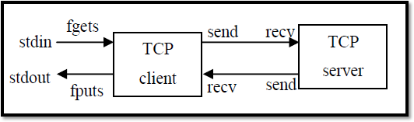

Echo client/server

A simple TCP client-server program where a client connects to the server. Server sends a message to the client which is displayed at the client side.

#### Client Code

# i n c l u d e *<* s t r i n g . h*>*

# i n c l u d e *<*a r p a / i n e t . h*>* # i n c l u d e *<* s t d l i b . h*>*

# i n c l u d e *<* s t d i o . h*>* # i n c l u d e *<*u n i s t d . h*>*

# i n c l u d e *<*s y s / s o c k e t . h*>* # i n c l u d e *<*s y s / t y p e s . h*>* # i n c l u d e *<* n e t i n e t / i n . h*>* # i n c l u d e *<* f c n t l . h*>*

# i n c l u d e *<*s y s / s t a t . h*>* main ( )

{

i n t s , r , recb , sntb , x ;

p r i n t f ( ” INPUT p o r t number : ” ) ; s c a n f (”% d ” , &x ) ;

s t r u c t s o c k a d d r i n s e r v e r ; c h a r b u f f [ 5 0 ] ;

s= s o c k e t ( AF INET , SOCK STREAM , 0 ) ;

i f ( s ==−1)

{

p r i n t f ( ” \ n Socket c r e a t i o n e r r o r . ” ) ; e x i t ( 0 ) ;

}

p r i n t f ( ” \ n Socket c r e a t e d . ” ) ; s e r v e r . s i n f a m i l y =AF INET ;

s e r v e r . s i n p o r t = h t o n s ( x ) ;

s e r v e r . s i n a d d r . s a d d r = i n e t a d d r ( ” 1 2 7 . 0 . 0 . 1 ” ) ;

r = c o n n e c t ( s , ( s t r u c t s o c k a d d r ∗)& s e r v e r , s i z e o f ( s e r v e r ) ) ; i f ( r ==−1)

{

p r i n t f ( ” \ n Conne c t i on e r r o r . ” ) ; e x i t ( 0 ) ;

}

p r i n t f ( ” \ n Socket c o n n e c t e d . ” ) ; p r i n t f ( ” \ n\ n ” ) ;

p r i n t f ( ” Type Message : ” ) ; s c a n f (”% s ” , b u f f ) ;

s n t b = send ( s , buff , s i z e o f ( b u f f ) , 0 ) ; i f ( s n t b ==−1)

{

c l o s e ( s ) ;

p r i n t f ( ” \ n Message Sending F a i l e d ” ) ; e x i t ( 0 ) ;

}

r e c b = r e c v ( s , buff , s i z e o f ( b u f f ) , 0 ) ; i f ( r e c b ==−1)

{

p r i n t f ( ” \ n Message R e c i e v i n g F a i l e d ” ) ; c l o s e ( s ) ;

e x i t ( 0 ) ;

}

p r i n t f ( ” \ n Message Recieved : ” ) ; p r i n t f (”% s ” , b u f f ) ;

p r i n t f ( ” \ n\ n ” ) ; c l o s e ( s ) ;

}

#### Server Code

# i n c l u d e *<* s t r i n g . h*>* # i n c l u d e *<*u n i s t d . h*>*

# i n c l u d e *<*s y s / s o c k e t . h*>* # i n c l u d e *<*s y s / t y p e s . h*>* # i n c l u d e *<* n e t i n e t / i n . h*>* # i n c l u d e *<* s t d l i b . h*>*

# i n c l u d e *<* s t d i o . h*>* main ( )

{

i n t s , r , recb , sntb , x , ns , a = 0 ;

p r i n t f ( ” INPUT p o r t number : ” ) ; s c a n f (”% d ” , &x ) ;

s o c k l e n t l e n ;

s t r u c t s o c k a d d r i n s e r v e r , c l i e n t ; c h a r b u f f [ 5 0 ] ;

s= s o c k e t ( AF INET , SOCK STREAM , 0 ) ;

i f ( s ==−1)

{

p r i n t f ( ” \ n Socket c r e a t i o n e r r o r . ” ) ; e x i t ( 0 ) ;

}

p r i n t f ( ” \ n Socket c r e a t e d . ” ) ; s e r v e r . s i n f a m i l y =AF INET ;

s e r v e r . s i n p o r t = h t o n s ( x ) ;

s e r v e r . s i n a d d r . s a d d r = h t o n l ( INADDR ANY ) ;

r = b i nd ( s , ( s t r u c t s o c k a d d r ∗)& s e r v e r , s i z e o f ( s e r v e r ) ) ; i f ( r ==−1)

{

p r i n t f ( ” \ n Binding e r r o r . ” ) ; e x i t ( 0 ) ;

}

p r i n t f ( ” \ n Socket b i n d e d . ” ) ; r = l i s t e n ( s , 1 ) ;

i f ( r ==−1)

{

c l o s e ( s ) ;

e x i t ( 0 ) ;

}

p r i n t f ( ” \ n Socket l i s t e n i n g . ” ) ; l e n = s i z e o f ( c l i e n t ) ;

ns= a c c e p t ( s , ( s t r u c t s o c k a d d r ∗)& c l i e n t , &l e n ) ; i f ( ns ==−1)

{

c l o s e ( s ) ;

e x i t ( 0 ) ;

}

p r i n t f ( ” \ n Socket a c c e p t i n g . ” ) ;

r e c b = r e c v ( ns , buff , s i z e o f ( b u f f ) , 0 ) ; i f ( r e c b ==−1)

{

p r i n t f ( ” \ n Message R e c i e v i n g F a i l e d ” ) ; c l o s e ( s ) ;

c l o s e ( ns ) ; e x i t ( 0 ) ;

}

p r i n t f ( ” \ n Message Recieved : ” ) ;

p r i n t f (”% s ” , b u f f ) ;

p r i n t f ( ” \ n\ n ” ) ;

s c a n f (”% s ” , b u f f ) ;

s n t b = send ( ns , buff , s i z e o f ( b u f f ) , 0 ) ; i f ( s n t b ==−1)

{

p r i n t f ( ” \ n Message Sending F a i l e d ” ) ; c l o s e ( s ) ;

c l o s e ( ns ) ; e x i t ( 0 ) ;

}

c l o s e ( ns ) ; c l o s e ( s ) ;

}

Steps to execute the program:

1. Open two terminal windows and open a text file from each terminal with .c extension using command: gedit filename.c
2. Type the client and server program in separate text files and save it before exiting the text window.
3. First compile and run the server using commands mentioned below
   1. gcc -o filename
   2. ./a.out or ./filename
4. Compile and run the client using the same instructions as listed in 3a and 3b

Note: The ephemeral port number has to be changed every time the program is executed.

## Lab Exercises:

1. Write two separate C programs (one for server and other for client) using socket APIs for TCP, to implement the client-server model such that the client should send a set of integers along with a choice to search for a number or sort the given set in ascending/descending order or split the given set to odd and even to the server. The server performs the relevant operation according to the choice. Client should continue to send the messages until the user enters selects the choice “exit”.
2. Write two separate C programs (one for server and other for client) using UNIX socket APIs for UDP, in which the client accepts a string from the user and sends it to the server. The server will check if the string is palindrome or not and send the result with the length of the string and the number of occurrences of each vowel in the string to the client. The client displays the received data on the client screen. The process repeats until user enter the string “Halt”. Then both the processes terminate. (The program should make use of TCP and UDP separately).

## Additional Exercise:

1. Write two separate C programs (one for the Server and the other for Client) using UNIX socket APIs using both connection oriented and connectionless services, in which the server displays the client’s socket address, IP address and port number on the server screen.

# Lab No. 2: Chat Server using Socket Programming

## Objectives

1. To contrast different modes of communication by implementing half duplex and full duplex chat server in connectionless and connection oriented environment.
2. To illustrate the use of fork() system call in socket programming.

## Introduction

Writing a chat application with popular web applications stacks has traditionally been very hard. It involves polling the server for changes, keeping track of timestamps, and it’s a lot slower than it should be. Sockets have traditionally been the solution around which most real-time chat systems are architected, providing a bi-directional communication channel between a client and a server.

A chat server is a computer dedicated to providing the processing power to handle and maintain chatting and it users. This means that the server can push messages to clients and also support multiple clients to initiate the conversation. To develop a chat server model, it is important to understand the different types of server and the mode of communication supported.

## Basic Modes of Communication

Data communication can be either simplex, half duplex or full duplex which are described below.

1. Simplex Operation: In simplex operation, a network cable or communications channel can only send information in one direction; it’s a “one-way street”. Simplex operation is used in special types of technologies, especially ones that are

asymmetric. For example, one type of satellite Internet access sends data over the satellite only for downloads, while a regular dial-up modem is used for upload to the service provider. In this case, both the satellite link and the dial-up connection are operating in a simplex mode.

1. Half-Duplex Operation: Technologies that employ half-duplex operation are capable of sending information in both directions between two nodes, but only one direction or the other can be utilized at a time. This is a fairly common mode of operation when there is only a single network medium (cable, radio frequency and so forth) between devices. For example, in conventional Ethernet networks, any device can transmit, but only one may do so at a time. For this reason, regular Ethernet networks are often said to be “half-duplex”.
2. Full-Duplex Operation: In full-duplex operation, a connection between two devices is capable of sending data in both directions simultaneously. Full-duplex channels can be constructed either as a pair of simplex links or using one channel designed to permit bidirectional simultaneous transmissions. A full-duplex link can only connect two devices, so many such links are required if multiple devices are to be connected together.

## Types of Server

There are two types of servers.

* Iterative Server - this is the simplest form of server where a server process serves one client and after completing the first request, it takes request from another client. Meanwhile, another client keeps waiting. In other words, an iterative server iterates through each client, handling it one at a time.
* Concurrent Servers - this type of server runs multiple concurrent processes to serve many requests at a time because one process may take longer and another client cannot wait for so long. The simplest way to write a concurrent server under UNIX

is to fork a child process to handle each client separately. An alternative technique is to use threads instead (i.e., light-weight processes).

## Some System Calls

* fork() causes a process to duplicate. The child process is an almost-exact duplicate of the original parent process; it inherits a copy of its parent’s code, data, stack, open file descriptors, and signal table. However, the parent and child have different process id numbers and parent process id numbers.
* If fork() succeeds, it returns the PID of the child to the parent process, and returns 0 to the child process. If it fails, it returns -1 to the parent process and no child is created.

#### System Calls:

int getpid() int getppid()

getpid() and getppid() return a process’s id and parent process’s id numbers, respectively. They always succeed. The parent process id number of PID 1 is 1.

#### Simple fork example to display PID and PPID

# i n c l u d e *<* s t d i o . h*>* main ( )

{

i n t p i d ;

p r i n t f ( ” I ’m t h e o r i g i n a l p r o c e s s wit h PID %d and PPID %d . \ n ” , g e t p i d ( ) , g e t p p i d ( ) ) ;

p i d = f o r k ( ) ;

/ ∗ D u p l i c a t e . C h i l d and p a r e n t c o n t i n u e from h e r e . ∗ /

i f ( p i d ! = 0 ) / ∗ p i d i s non−zero , so I must be t h e p a r e n t ∗ /

{

p r i n t f ( ” I ’m t h e p a r e n t p r o c e s s wit h PID %d and PPID %d . \ n ” , g e t p i d ( ) , g e t p p i d ( ) ) ;

p r i n t f ( ”My c h i l d ’ s PID i s %d . \ n ” , p i d ) ;

}

e l s e / ∗ p i d i s zero , so I must be t h e c h i l d . ∗ /

{

p r i n t f ( ” I ’m t h e c h i l d p r o c e s s wit h PID %d and PPID %d . \ n ” , g e t p i d ( ) , g e t p p i d ( ) ) ;

}

p r i n t f ( ” PID %d t e r m i n a t e s . \ n ” , p i d ) ;

/ ∗ Both p r o c e s s e s e x e c u t e t h i s ∗ /

}

## Half Duplex TCP Chat Program

**Aim:** To implement a half-duplex application, where the Client establishes a connection with the Server. The client and server can send and receive messages one at a time.

#### Algorithm (TCP):

**Server:**

1. Include necessary header files.
2. Create a socket using socket function with family AF INET, type as SOCK STREAM.
3. Initialize the socket and set its attributes.Assign the sin family to AF INET, sin addr to INADDR ANY, sin port to dynamically assigned port number.
4. Bind the server to socket using bind function.
5. Listen to incoming client requests and wait for the client request. On connection request from the client establish a connection using accept() function.
6. Receive and display the message sent by the client.
7. Read the message from the console and send it to the client.
8. If the received message is “BYE” terminate the connection (kill the process).
9. Close the socket.

#### Client:

1. Include the necessary header files.
2. Create a socket using socket function with family AF INET, type as SOCK STREAM.
3. Initialize the socket and set its attribute set. Assign the sin family to AF INET, sin addr to “127.0.0.1”, sin port to dynamically assigned port number.
4. Connect to server using connect () function to initiate the request.
5. Read the message from the console and send it to the server using send call.
6. Receive the message from the server and display it.
7. If the received message is “BYE” terminate the connection (kill the process).
8. Close the socket.

## Full Duplex TCP Chat Program

**Aim:**To implement a full duplex application, where the Client establishes a connection with the Server. The Client and Server can send as well as receive messages at the same time. Both the Client and Server exchange messages.

#### Algorithm (TCP):

**Server:**

1. Include necessary header files.
2. Create a socket using socket function with family AF INET, type as SOCK STREAM.
3. Initialize the socket and set its attributes.Assign the sin family to AF INET, sin addr to INADDR ANY, sin port to dynamically assigned port number.
4. Bind the server to socket using bind function.
5. Listen to incoming client requests and wait for the client request. On connection request from the client establish a connection using accept () function.
6. Fork the process to create child process which is an exact copy of the calling process (parent process).
7. If the process is child receive the message from the client and display it. Else if the process is parent read the message from the console and send it to the client.
8. If the received message is “BYE” terminate the connection (kill the process).
9. Close the socket.

#### Client:

1. Include the necessary header files.
2. Create a socket using socket function with family AF INET, type as SOCK STREAM.
3. Initialize the socket and set its attribute set. Assign the sin family to AF INET, sin addr to “127.0.0.1”, sin port to dynamically assigned port number.
4. Connect to server using connect () function to initiate the request.
5. Fork the process to create child process which is an exact copy of the calling process (parent process).
6. If the process is child read the message from the console and send it to the server. If the process is parent receive the message from the server and display it.
7. If the received message is “BYE” terminate the connection (kill the process).
8. Close the socket.

**Note : Operations for UDP follows the same process but make necessary changes in the system calls.**

## Lab Exercises

1. Write two separate C programs using UNIX socket APIs illustrate full duplex mode chat application between a single client and server using connection oriented service. Display PID and PPID of both parent and child processes.
2. Write two separate C programs using UNIX socket APIs illustrate half duplex mode chat application between a single client and server connection less service in which the server estimates and prints all permutations of a string sent by the client.
3. Write two separate C programs (one for server and other for client) using socket APIs, to implement the following connection-oriented client-server model.
   1. The user at the client side sends an alphanumeric string to the server.
   2. The child process at the server sorts the numbers of the alphanumeric string in ascending order. The parent process at the server sorts the characters of the alphanumeric string in descending order.
   3. Both the processes send the results to the client along with its corresponding process ID.

**Sample Output:** At the client side:

Input string: hello451bye7324 At the server side:

Output at the child process of the server: 1234457 Output at the parent process of the server: yollheeb

## Additional Exercises

1. Write a C program to simulate a menu driven calculator using client server architecture that performs the following. The client prompts the user with the options as listed below 1. Add/Subtract two integers
2. Find the value of ’x’ in a linear equation
3. Multiply two matrices
4. Exit

Based on the user input the client prompts the user to enter required data. The client sends the option chosen and the relevant data to the server. The server performs the required operation and sends the result to the client. Note that if option 1 is selected, the server provides result of both addition and subtraction of the two integers.

# Lab No. 3: Multiple Clients Communication using Socket Programming

## Objectives

1. To implement multiple client communication with concurrent server.
2. To implement the services performed by an iterative DNS server to multiple clients using socket programming.

## Introduction

There are two main classes of servers, iterative and concurrent. An iterative server iterates through each client, handling it one at a time. A concurrent server handles multiple clients at the same time. The simplest technique for a concurrent server is to call the fork function, creating one child process for each client. An alternative technique is to use threads instead (i.e., light-weight processes).

#### Process-based using Fork:

* Spawn one server process to handle each client connection
* Kernel automatically interleaves multiple server processes
* Each server process has its own private address space

A typical concurrent server using fork has the following structure:

p i d t p i d ;

i n t l i s t e n f d , connfd ;

l i s t e n f d = s o c k e t ( . . . ) ;

/ ∗∗∗ f i l l t h e s o c k e t a d d r e s s wi t h s e r v e r ’ s w e l l known p o r t ∗∗ ∗ / b i nd ( l i s t e n f d , . . . ) ;

l i s t e n ( l i s t e n f d , . . . ) ;

f o r ( ; ; ) {

connfd = a c c e p t ( l i s t e n f d , . . . ) ; / ∗ b l o c k i n g c a l l ∗ / i f ( ( p i d = f o r k ( ) ) == 0 ) {

c l o s e ( l i s t e n f d ) ; / ∗ c h i l d c l o s e s l i s t e n i n g s o c k e t ∗ /

/ ∗∗ ∗ p r o c e s s t h e r e q u e s t doing something u s i n g connfd ∗∗ ∗ /

/ ∗ . . . . . . . . . . . . . . . . . ∗ /

c l o s e ( connfd ) ;

e x i t ( 0 ) ; / ∗ c h i l d t e r m i n a t e s

}

c l o s e ( connfd ) ; / ∗ p a r e n t c l o s e s c o n n e c t e d s o c k e t ∗ /

}

}

When a connection is established, accept returns, the server calls fork, and the child process services the client (on the connected socket connfd). The parent process waits for another connection (on the listening socket listenfd). The parent closes the connected socket since the child handles the new client. The interactions among client and server are presented in Figure.

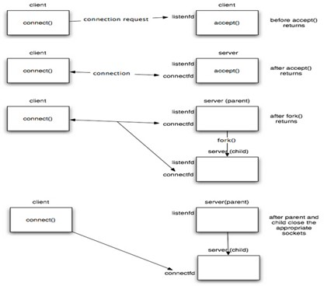

#### TCP Iterative Server Example

# i n c l u d e *<* s t d l i b . h*>* # i n c l u d e *<* s t d i o . h*>*

# i n c l u d e *<*s y s / t y p e s . h*>* # i n c l u d e *<*s y s / s o c k e t . h*>* # i n c l u d e *<* n e t i n e t / i n . h*>* # i n c l u d e *<* s t r i n g . h*>*

# i n c l u d e *<* u n i s t d . h*>*

# d e f i n e MAXLINE 4096 / ∗ max t e x t l i n e l e n g t h ∗ / # d e f i n e SERV PORT 3000 / ∗ p o r t ∗ /

# d e f i n e LISTENQ 8 / ∗ maximum number of c l i e n t c o n n e c t i o n s ∗ / i n t main ( i n t a r g c , c h a r ∗∗ a rg v )

{

i n t l i s t e n f d , connfd , n ; s o c k l e n t c l i l e n ;

c h a r buf [MAXLINE ] ;

s t r u c t s o c k a d d r i n c l i a d d r , s e r v a d d r ;

/ / c r e a t i o n of t h e s o c k e t

l i s t e n f d = s o c k e t ( AF INET , SOCK STREAM, 0 ) ;

/ / p r e p a r a t i o n of t h e s o c k e t a d d r e s s s e r v a d d r . s i n f a m i l y = AF INET ;

s e r v a d d r . s i n a d d r . s a d d r = h t o n l ( INADDR ANY ) ; s e r v a d d r . s i n p o r t = h t o n s ( SERV PORT ) ;

b i nd ( l i s t e n f d , ( s t r u c t s o c k a d d r ∗) &s e r v a d d r , s i z e o f ( s e r v a d d r ) ) ;

l i s t e n ( l i s t e n f d , LISTENQ ) ;

p r i n t f (”% s \ n ” , ” S e r v e r r u n n i n g . . . w a i t i n g f o r c o n n e c t i o n s . ” ) ; f o r ( ; ; ) {

c l i l e n = s i z e o f ( c l i a d d r ) ;

connfd = a c c e p t ( l i s t e n f d , ( s t r u c t s o c k a d d r ∗) &c l i a d d r , & c l i l e n ) ;

p r i n t f (”% s \ n ” , ” Received r e q u e s t . . . ” ) ;

w h i l e ( ( n = r e c v ( connfd , buf , MAXLINE, 0 ) ) *>* 0 ) {

p r i n t f (”% s ” , ” S t r i n g r e c e i v e d from and r e s e n t t o t h e c l i e n t : ” ) ; p u t s ( buf ) ;

send ( connfd , buf , n , 0 ) ;

}

i f ( n *<* 0 ) {

p e r r o r ( ” Read e r r o r ” ) ; e x i t ( 1 ) ;

}

c l o s e ( connfd ) ;

}

/ / c l o s e l i s t e n i n g s o c k e t c l o s e ( l i s t e n f d ) ;

}

#### TCP Concurrent server Using Fork

# i n c l u d e *<* s t d l i b . h*>* # i n c l u d e *<* s t d i o . h*>*

# i n c l u d e *<*s y s / t y p e s . h*>*

# i n c l u d e *<*s y s / s o c k e t . h*>* # i n c l u d e *<* n e t i n e t / i n . h*>* # i n c l u d e *<* s t r i n g . h*>*

# i n c l u d e *<* u n i s t d . h*>*

# d e f i n e MAXLINE 4096 / ∗ max t e x t l i n e l e n g t h ∗ / # d e f i n e SERV PORT 3000 / ∗ p o r t ∗ /

# d e f i n e LISTENQ 8 / ∗ maximum number of c l i e n t c o n n e c t i o n s ∗ /

i n t main ( i n t a r g c , c h a r ∗∗ a rg v )

{

I n t l i s t e n f d , connfd , n ; p i d t c h i l d p i d ;

s o c k l e n t c l i l e n ; c h a r buf [MAXLINE ] ;

s t r u c t s o c k a d d r i n c l i a d d r , s e r v a d d r ;

/ / C r e a t e a s o c k e t

/ / I f sockfd *<*0 t h e r e was an e r r o r i n t h e c r e a t i o n of t h e s o c k e t i f ( ( l i s t e n f d = s o c k e t ( AF INET , SOCK STREAM, 0 ) ) *<*0) {

p e r r o r ( ” Problem i n c r e a t i n g t h e s o c k e t ” ) ; e x i t ( 2 ) ;

}

/ / p r e p a r a t i o n of t h e s o c k e t a d d r e s s s e r v a d d r . s i n f a m i l y = AF INET ;

s e r v a d d r . s i n a d d r . s a d d r = h t o n l ( INADDR ANY ) ; s e r v a d d r . s i n p o r t = h t o n s ( SERV PORT ) ;

/ / b i nd t h e s o c k e t

b i nd ( l i s t e n f d , ( s t r u c t s o c k a d d r ∗) &s e r v a d d r , s i z e o f ( s e r v a d d r ) ) ;

/ / l i s t e n t o t h e s o c k e t by c r e a t i n g a c o n n e c t i o n queue , t h e n w a i t f o r l i s t e n ( l i s t e n f d , LISTENQ ) ;

p r i n t f (”% s \ n ” , ” S e r v e r r u n n i n g . . . w a i t i n g f o r c o n n e c t i o n s . ” ) ;

f o r ( ; ; ) {

c l i l e n = s i z e o f ( c l i a d d r ) ;

/ / a c c e p t a c o n n e c t i o n

connfd = a c c e p t ( l i s t e n f d , ( s t r u c t s o c k a d d r ∗) &c l i a d d r , & c l i l e n ) ; p r i n t f (”% s \ n ” , ” Received r e q u e s t . . . ” ) ;

i f ( ( c h i l d p i d = f o r k ( ) ) = = 0 ) { / / i f i t ’ s 0 , i t ’ s c h i l d p r o c e s s

p r i n t f (”% s \ n ” , ” C h i l d c r e a t e d f o r d e a l i n g wit h c l i e n t r e q u e s t s ” ) ;

/ / c l o s e l i s t e n i n g s o c k e t c l o s e ( l i s t e n f d ) ;

w h i l e ( ( n = r e c v ( connfd , buf , MAXLINE, 0 ) ) *>* 0 ) {

p r i n t f (”% s ” , ” S t r i n g r e c e i v e d from and r e s e n t t o t h e c l i e n t : ” ) ; p u t s ( buf ) ;

send ( connfd , buf , n , 0 ) ;

}

i f ( n *<* 0 )

p r i n t f (”% s \ n ” , ” Read e r r o r ” ) ; e x i t ( 0 ) ;

}

/ / c l o s e s o c k e t of t h e s e r v e r c l o s e ( connfd ) ;

}

}

## Lab Exercises

1. Write a single server and multiple client program to illustrate multiple clients communicating with a concurrent server. The client1 on establishing successful connection sends ”Institute Of” string to the server along with its socket address. The client2 on establishing successful connection sends ”Technology” string to the server along with its socket address. The server opens a text file having the keyword ”Manipal”, append the keywords ”Institute of” and ”Technology” and displays ”Manipal Institute of Technology” along with the socket addresses of the clients . If the number of clients connected exceeds 2, the server sends ”terminate session” to all clients and the program terminates.
2. Write a single server multiple client program to illustrate multiple clients communicating with a single iterative server. The client on establishing successful connection prompts the user to enter 2 strings which is sent to the server along with client socket address. The server checks whether the strings are anagrams or not and

sends an appropriate message to the client. The result obtained is then displayed on the client side. The server displays the date and time along with client socket address that it is connected to it at any instant.

## Additional Exercise

1. Write C program to simulate travel ticket reservation system. Where the server displays the number of seats available and the number of seats booked of two different source and destination locations. Multiple clients try to connect to server and sends the number of seats to be booked as entered by the user. The server database has to be updated and the client should terminate its session after successful seat reservation. Note that if the requested number of seats are unavailable the server sends appropriate message to the client and the client program terminates. Price of ticket need not be taken into consideration.

# Lab No. 4: Implementation of Error Detection and Error Correction Techniques.

## Objectives

* Design and Implementation of Error detection in transmitted data at the receiver side using Parity check and Cyclic Redundancy Check.
* Design and Implementation of error detection and error correction in transmitted data at the receiver side using Hamming code.

**Error Control Mechanism**

Error control mechanism plays an important role in the transmission of data from one source to another. The noise also gets added into the data when it transmits from one system to another, which causes errors in the received binary data at other systems. The bits of the data may change (either 0 to 1 or 1 to 0) during transmission.

Error control mechanism may involve two possible ways:

* Error detection
* Error correction

It is impossible to avoid the interference of noise, but it is possible to get back the original data. For this purpose, we first need to detect either an error z is present or not using error detection codes. If the error is present in the code, then we will correct it with the help of error correction codes. The error detection codes are the code used for detecting the error in the received data bitstream. In these codes, some bits are included appended to the original bitstream.

## Types of Errors

There may be three types of errors:

To detect errors, a common technique is to introduce redundancy bits that provide additional information. Various techniques for error detection include:: Parity check, Checksum, and CRC

Error-detecting codes encode the message before sending it over the noisy channels. The encoding scheme is performed in such a way that the decoder at the receiving can find the errors easily in the receiving data with a higher chance of success.

* These codes are used when we use message backward error correction techniques for reliable data transmission. A feedback message is sent by the receiver to inform the sender whether the message is received without any error or not at the receiver side. If the message contains errors, the sender retransmits the message.
* In error detection codes, in fixed-size blocks of bits, the message is contained. In this, the redundant bits are added for correcting and detecting errors.
* These codes involve checking of the error. No matter how many error bits are there and the type of error.
* Parity check, Checksum, and CRC are the error detection techniques.

### Algorithm

**Parity check:**

One extra bit is sent along with the original bits to make number of 1s either even in case of even parity, or odd in case of odd parity.

The sender while creating a frame counts the number of 1s in it. For example, if even parity is used and number of 1s is even then one bit with value 0 is added. This way number of 1s remains even.If the number of 1s is odd, to make it even a bit with value 1 is added.

Even Parity

The receiver simply counts the number of 1s in a frame. If the count of 1s is even and even parity is used, the frame is considered to be not-corrupted and is accepted. If the count of 1s is odd and odd parity is used, the frame is still not corrupted.

If a single bit flips in transit, the receiver can detect it by counting the number of 1s. But when more than one bits are erro neous, then it is very hard for the receiver to detect the error.

#### At sender side:

1. Start the program
2. Total number of 1’s in the data unit to be transmitted is counted.
3. The total number of 1’s in the data unit is made even in case of even parity.

The total number of 1’s in the data unit is made odd in case of odd parity.

1. This is done by adding an extra bit called as parity bit.
2. The newly formed code word (Original data + parity bit) is transmitted to the receiver.
3. Stop the program

#### At receiver side :

1. Start the program
2. Receiver receives the transmitted code word.
3. The total number of 1’s in the received code word is counted.

Then, following cases are possible-

1. If total number of 1’s is even and even parity is used, then receiver assumes that no error occurred.
2. If total number of 1’s is even and odd parity is used, then receiver assumes that error occurred.
3. If total number of 1’s is odd and odd parity is used, then receiver assumes that no error occurred.
4. If total number of 1’s is odd and even parity is used, then receiver assumes that error occurred.
5. Stop

**Cyclic Redundancy Check:**

CRC is a different approach to detect if the received frame contains valid data. This technique involves binary division of the data bits being sent. The divisor is generated using polynomials. The sender performs a division operation on the bits being sent and calculates the remainder. Before sending the actual bits, the sender adds the remainder at the end of the actual bits. Actual data bits plus the remainder is called a codeword. The sender transmits data bits as codewords.

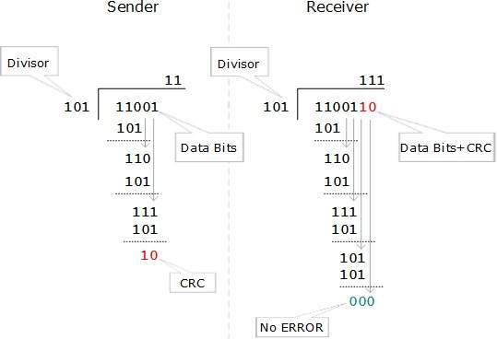

At the other end, the receiver performs division operation on codewords using the same CRC divisor. If the remainder contains all zeros the data bits are accepted, otherwise it is considered as there some data corruption occurred in transit.

#### At sender side:

1. Start the program
2. A string of n 0’s is appended to the data unit to be transmitted. Here, n is one less than the number of bits in CRC generator.
3. Binary division is performed of the resultant string with the CRC generator.
4. After division, the remainder so obtained is called as CRC. It may be noted that CRC also consists of n bits.
5. The CRC is obtained after the binary division. The string of n 0’s appended to the data unit earlier is replaced by the CRC remainder.
6. The newly formed code word (Original data + CRC) is transmitted to the receiver.
7. Stop

#### At receiver side:

1. Start the program
2. The transmitted code word is received.
3. The received code word is divided with the same CRC generator.
4. On division, the remainder so obtained is checked.
   1. If the remainder is zero, Receiver assumes that no error occurred in the data during the transmission. Receiver accepts the data.
   2. If the remainder is non-zero, Receiver assumes that some error occurred in the data during the transmission. Receiver rejects the data and asks the sender for retransmission.
5. Stop

## Error Correction:

In the digital world, error correction can be done in two ways:

* **Backward Error Correction:** When the receiver detects an error in the data received, it requests back the sender to retransmit the data unit.
* **Forward Error Correction:** When the receiver detects some error in the data received, it executes error-correcting code, which helps it to auto-recover and to correct some kinds of errors.

The first one, Backward Error Correction, is simple and can only be efficiently used where retransmitting is not expensive. For example, fiber optics. But in case of wireless transmission retransmitting may cost too much. In the latter case, Forward Error Correction is used.

A single additional bit can detect the error, but cannot correct it. For correcting the errors, one has to know the exact position of the error. For example, If we want to calculate a single-bit error, the error correction code will determine which one of seven bits is in error. To achieve this, we have to add some additional redundant bits. Suppose r is the number of redundant bits and d is the total number of the data bits. The number of redundant bits r can be calculated by using the formula: 2r >= d + r + 1. The value of r is calculated by using the above formula. For example, if the value of d is 4, then the possible smallest value that satisfies the above relation would be 3. To determine the position of the bit which is in error, a technique developed by R.W Hamming is Hamming code which can be applied to any length of the data unit and uses the relationship between data units and redundant units.

There are several types of block codes, including:

* **Hamming Codes:** Hamming codes are a type of block code that can detect and correct single-bit errors. They are commonly used in digital systems to ensure the accuracy of transmitted data.
* **Reed-Solomon Codes:** Reed-Solomon codes are a type of block code that can correct multiple-bit errors. They are commonly used in storage systems, such as CD-ROMs and DVDs, to ensure the integrity of stored data.
* **BCH Codes:** BCH (Bose–Chaudhuri–Hocquenghem) codes are a type of block code that can correct a specific number of errors. They are commonly used in digital communication systems to ensure the accuracy of transmitted data.

**Hamming Code**

It is a technique developed by R.W. Hamming for error correction. The number of redundant bits can be calculated using the following formula: 2r ≥ m + r + 1 where, r = redundant bit, m = data bit. Suppose the number of data bits is 7, then the number of redundant bits can be calculated using: = 24 ≥ 7 + 4 + 1 Thus, the number of redundant bits= 4 Parity bits.

Hamming Code is simply the use of extra parity bits to allow the identification of an error.

#### At sender side:

1. Start the program
2. Write the bit positions starting from 1 in binary form (1, 10, 11, 100, etc).
3. All the bit positions that are a power of 2 are marked as parity bits (1, 2, 4, 8, etc). All the other bit positions are marked as data bits.



1. Each data bit is included in a unique set of parity bits, as determined its bit position in binary form.
   1. Parity bit 1 covers all the bits positions whose binary representation includes a 1 in the least significant position (1, 3, 5, 7, 9, 11, etc).
   2. Parity bit 2 covers all the bits positions whose binary representation includes a 1 in the second position from the least significant bit (2, 3, 6, 7, 10, 11, etc).
   3. Parity bit 4 covers all the bits positions whose binary representation includes a 1 in the third position from the least significant bit (4–7, 12–15, 20–23, etc).
   4. Parity bit 8 covers all the bits positions whose binary representation includes a 1 in the fourth position from the least significant bit bits (8–15, 24–31, 40–47, etc).
   5. In general, each parity bit covers all bits where the bitwise AND of the parity position and the bit position is non-zero.
2. Check for even parity set a parity bit to 1 if the total number of ones in the positions it checks is odd. Set a parity bit to 0 if the total number of ones in the positions it checks is even.



1. Stop

#### At receiver side:

1. Start the program
2. For all the parity bits we will check the number of 1’s in their respective bit positions.
   1. For R1: bits 1, 3, 5, 7, 9, 11. We can see that the number of 1’s in these bit positions are 3 and that’s even so we get a 1 for this.
   2. For R2: bits 2,3,6,7,10,11 . We can see that the number of 1’s in these bit positions are 3 and that’s odd so we get a 1 for this.
   3. For R4: bits 4, 5, 6, 7 . We can see that the number of 1’s in these bit positions are 1 and that’s odd so we get a 1 for this.
   4. For R8: bit 8,9,10,11 . We can see that the number of 1’s in these bit positions are 2 and that’s even so we get a 0 for this.



1. The bits give the binary number 0111 whose decimal representation is 7. Thus, bit 7 contains an error. To correct the error the 7th bit is changed from 0 to 1.
2. Stop

## Lab Exercises

1. Write a C program to transmit the data (binary values) from the sender side to receiver. The receiver side has to check whether the transmit data is corrupt or not using the parity technique – odd or even parity.
2. Write a C program to transmit the data (set of characters) from the sender side to receiver. The receiver side must check whether the transmit data is corrupted or not corrupted using the CRC polynomial techniques – CRC 12, CRC 16, CRC CCIP.
3. Implement the Hamming code method to detect the error in transmitted data and correct the error bit in the transmitted data.

# Lab No. 5: Application Development using Socket Programming

## Obj/ectives

* To apply the socket programming concepts in developing the real-world applications
* communication using Python)

In the network layer, before the network can make Quality of service guarantees, it must know what traffic is being guaranteed. One of the main causes of congestion is that traffic is often bursty. The congesting control algorithms are basically divided into two groups: open loop and closed loop. Open loop solutions attempt to solve the problem by good design, in essence, to make sure it does not occur in the first place. Once the system is up and running, midcourse corrections are not made. Open loop algorithms are further divided into ones that act at source versus ones that act at the destination.

In contrast, closed loop solutions are based on the concept of a feedback loop if there is any congestion. Closed loop algorithms are also divided into two subcategories: explicit feedback and implicit feedback. In explicit feedback algorithms, packets are sent back from the point of congestion to warn the source. In implicit algorithm, the source deduces the existence of congestion by making local observation, such as the time needed for acknowledgment to come back.

The presence of congestion means that the load is (temporarily) greater than the resources (in part of the system) can handle. For subnets that use virtual circuits internally, these methods can be used at the network layer. Another open loop method to help manage congestion is forcing the packet to be transmitted at a more predictable rate. This approach to congestion management is widely used in ATM networks and is called traffic shaping.

To understand this concept first we have to know little about traffic shaping. Traffic Shaping is a mechanism to control the amount and the rate of traffic sent to the network. Approach of congestion management is called Traffic shaping. Traffic shaping helps to regulate the rate of data transmission and reduces congestion.

There are 2 types of traffic shaping algorithms:

* Leaky Bucket
* Token Bucket

**Leaky Bucket**

Suppose we have a bucket in which we are pouring water, at random points in time, but we have to get water at a fixed rate, to achieve this we will make a hole at the bottom of the bucket. This will ensure that the water coming out is at some fixed rate, and also if the bucket gets full, then we will stop pouring water into it. The input rate can vary, but the output rate remains constant. Similarly, in networking, a technique called leaky bucket can smooth out bursty traffic. Bursty chunks are stored in the bucket and sent out at an average rate.

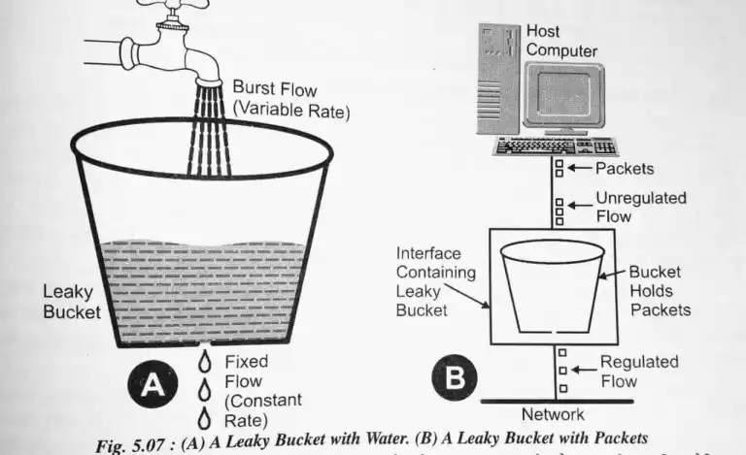

Each host is connected to the network by an interface containing a leaky bucket, that is, a finite internal queue. If a packet arrives at the queue when it is full, the packet is discarded. In other words, if one or more process are already queued, the new packet is unceremoniously discarded. This arrangement can be built into the hardware interface or simulate d by the host operating system. In fact it is nothing other than a single server queuing system with constant service time.

The host is allowed to put one packet per clock tick onto the network. This mechanism turns an uneven flow of packet from the user process inside the host into an even flow of packet onto the network, smoothing out bursts and greatly reducing the chances of congestion.

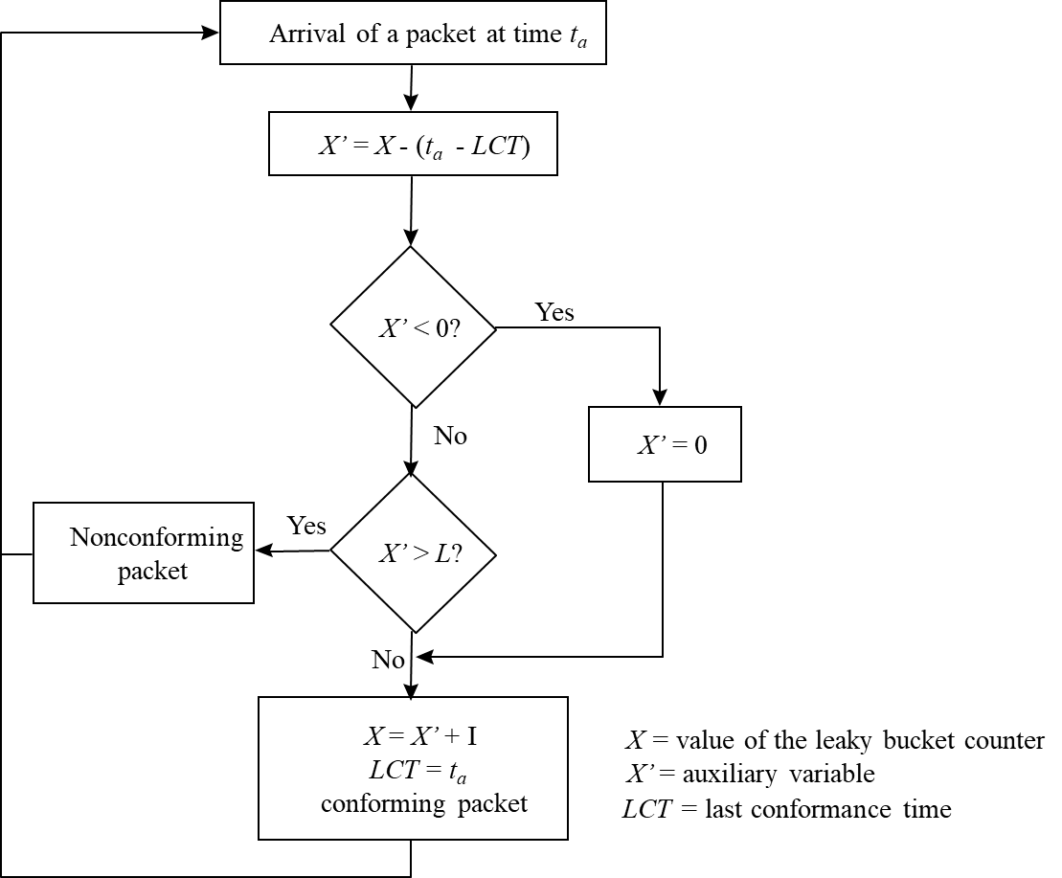

**Algorithm:**

1. Start the program
2. Set the bucket size or the buffer size.
3. Set the output rate.
4. Transmit the packets such that there is no overflow.
5. Repeat the process of transmission until all packets are transmitted. (Reject packets where its size is greater than the bucket size)
6. Stop

**Token Bucket**

The leaky bucket algorithm enforces output patterns at the average rate, no matter how busy the traffic is. So, to deal with more traffic, we need a flexible algorithm so that the data is not lost. One such approach is the token bucket algorithm. When compared to the Leaky bucket the token bucket algorithm is less restrictive which means it allows more traffic. The limit of busyness is restricted by the number of tokens available in the bucket at a particular instant of time.

In some applications, when large bursts arrive, the output is allowed to speed up. This calls for a more flexible algorithm, preferably one that never loses information. Therefore, a token bucket algorithm finds its uses in network traffic shaping or rate-limiting. It is a control algorithm that indicates when traffic should be sent. This order comes based on the display of tokens in the bucket. The bucket contains tokens. Each of the tokens defines a packet of predetermined size. Tokens in the bucket are deleted for the ability to share a packet. When tokens are shown, a flow to transmit traffic appears in the display of tokens. No token means no flow sends its packets. Hence, a flow transfers traffic up to its peak burst rate in good tokens in the bucket.

The implementation of the token bucket algorithm is easy − a variable is used to count the tokens. For every t seconds the counter is incremented and then it is decremented whenever a packet is sent. When the counter reaches zero, no further packet is sent out.

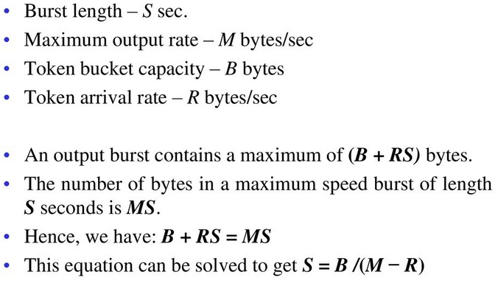

**Algorithm:**

1. Start the program
2. In regular intervals, tokens are thrown into the bucket f.
3. The bucket has a maximum capacity f.
4. If the packet is ready, then a token is removed from the bucket, and the packet is sent.
5. Suppose, if there is no token in the bucket, the packet cannot be sent.
6. Stop

## Lab Exercises

1. Write a C program to avoid the congestion in network by using the leaky bucket method. Suppose the network packets arrive at a leaky bucket policer at time interval t = 1, 2, 3, 5, 6, 8, 11, 12, 15, 16, and 19 seconds with a packet size of 4 bytes each. Assume that the leaky bucket size X= 10 (queue size) bytes and the outgoing rate is one byte for every second. Identify the conforming and nonconforming packets in the queue and display the process on the screen.
2. Write a C program to avoid the congestion in network by using the Token bucket method. Assume that we have a token bucket shaper that has a replenishment rate r = 10 KBps, an infinite maximum rate R, a bucket size b = 50 Kbytes and that the bucket starts off full. Also assume that a sender emits 15 Kbytes packet size every 0.5 seconds in a periodic manner, starting at t = 0.5 seconds. For this question, you can assume that if sufficient tokens are available, packets pass through the token bucket instantaneously, otherwise they are queued until there are.
3. How many tokens are left in the bucket after 1.5 seconds?
4. How long will it take until packets start to be queued or dropped?
5. Now, presume the sender can send as much as they want, whenever they want. If the token bucket is changed to enforce a maximum rate R of 20 KBps, what would the maximum possible burst size be?

# Lab No. 8: Prototyping the Network Model using Packet Tracer

## Objectives

* + 1. Develop an understanding of the basic functions of Packet Tracer.
    2. To build a network using packet tracer
    3. To demonstrate use of different network components such as routers, switches etc
    4. Observe traffic behavior on the network.

## Introduction

Cisco Packet Tracer is a powerful network simulation program that allows students to experiment with network behavior and ask “what if” questions. As an integral part of the Networking Academy comprehensive learning experience, Packet Tracer provides simulation, visualization, authoring, assessment, and collaboration capabilities and facilitates the teaching and learning of complex technology concepts.

Packet Tracer supplements physical equipment in the classroom by allowing students to create a network with an almost unlimited number of devices, encouraging practice, discovery, and troubleshooting. The simulation-based learning environment helps students develop 21st century skills such as decision making, creative and critical thinking, and problem solving. Packet Tracer complements the Networking Academy curricula, allowing instructors to easily teach and demonstrate complex technical concepts and networking systems design.

Packet Tracer complements the Networking Academy curricula, allowing instructors to easily teach and demonstrate complex technical concepts and networking systems design. Instructors can customize individual or multiuser activities, providing hands-on lessons for students that offer value and relevance in their classrooms. Students can build,

configure, and troubleshoot networks using virtual equipment and simulated connections, alone or in collaboration with other students. Packet Tracer offers an effective, interactive environment for learning networking concepts and protocols. Most importantly, Packet Tracer helps students and instructors create their own virtual “network worlds” for exploration, experimentation, and explanation of networking concepts and technologies.

## Key Features

Packet Tracer Workspaces: Cisco Packet Tracer has two workspaces—logical and physical. The logical workspace allows users to build logical network topologies by placing, connecting, and clustering virtual network devices. The physical workspace provides a graphical physical dimension of the logical network, giving a sense of scale and placement in how network devices such as routers, switches, and hosts would look in a real environment. The physical view also provides geographic representations of networks, including multiple cities, buildings, and wiring closets.

## Packet Tracer Modes

Cisco Packet Tracer provides two operating modes to visualize the behavior of a network—real-time mode and simulation mode. In real-time mode the network behaves as real devices do, with immediate real-time response for all network activities. The real-time mode gives students a viable alternative to real equipment and allows them to gain configuration practice before working with real equipment. In simulation mode the user can see and control time intervals, the inner workings of data transfer, and the propagation of data across a network. This helps students understand the fundamental concepts behind network operations. A solid understanding of network fundamentals can help accelerate learning about related concepts.

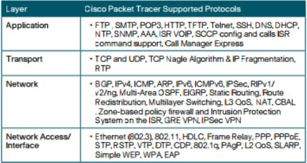Protocols: Cisco Packet Tracer supports the following protocols

A client has requested that you set up a simple network with two PCs connected to a switch. Verify that the hardware, along with the given configurations, meet the requirements of the client. Following are the steps to setup the above given scenario:

#### Step 1: Set up the network topology

1. Add two PCs and a Cisco 2950T switch.
2. Using straight-through cables, connect PC0 to interface Fa0/1 on Switch0 and PC1 to interface Fa0/2 on Switch0.
3. Configure PC0 using the Config tab in the PC0 configuration window: 1. IP address: 192.168.10.10

2. Subnet Mask 255.255.255.0

1. Configure PC1 using the Config tab in the PC1 configuration window: 1. IP address: 192.168.10.11

2. Subnet Mask 255.255.255.

#### Step 2: Test connectivity from PC0 to PC1

1. Use the ping command to test connectivity.
2. Click PC0.
3. Choose the Desktop tab.
4. Choose Command Prompt.
5. Type: ping 192.168.10.11 and press enter.
6. A successful ping indicates the network was configured correctly and the prototype

validates the hardware and software configurations. A successful ping should resemble the below output:

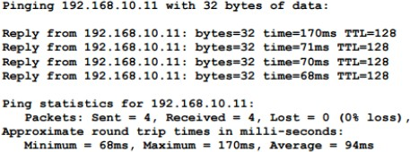

1. Close the configuration window.

## Communication between 2 PC’s via the router

Here, we will see communication enabled between PCs via Router in Packet Tracer. So, for this we need two PCs, a router, and two cross over cables to connect them. Important point is that we use cross over cable to connect PC to a router because they both use the same pins for transmission and receiving of data.

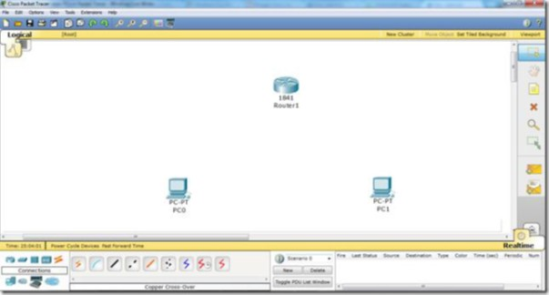

Now, we will connect them by selecting fast ethernet interfaces on both ends.

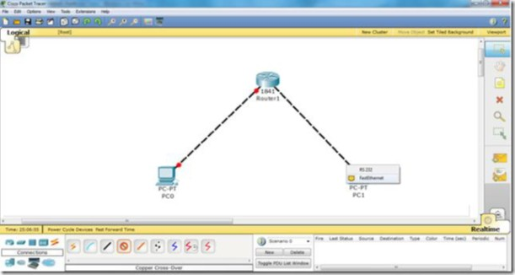

Now, we have connect the devices. Further, we will go to the router CLI mode and enter the following commands. Step by step, we will have to do the following things.

1. Access the interfaces one by one
2. Assign IP addresses to interfaces
3. Change the status of the interfaces i.e. from Down to Up
4. Assign IP addresses to PCs
5. Assign Default Gateway to PCs. FYI fast Ethernet ip address is the gateway address to the PC

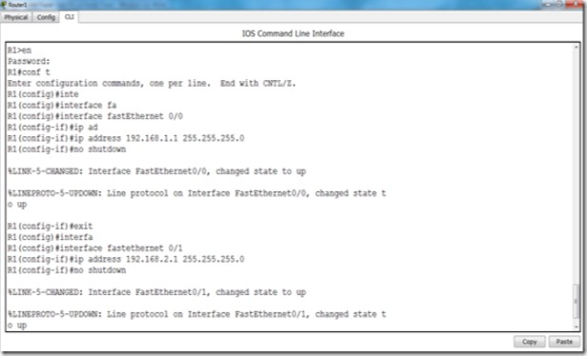

Now, we have accessed both interfaces one by one and we have assigned IP addresses respectively.

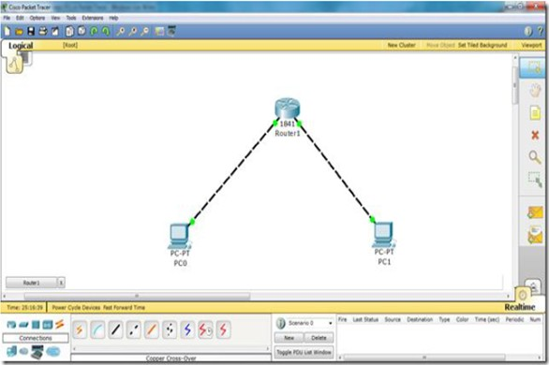

Now, we have accessed both interfaces one by one and we have assigned IP addresses respectively.

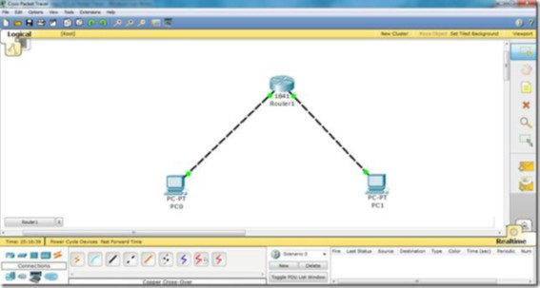

See the difference the lights have changed the color from Red to Green. Now, lets assign IP addresses to the PCs. Click on PC0, go to Desktop, then click IP Configuration.

#### PC0

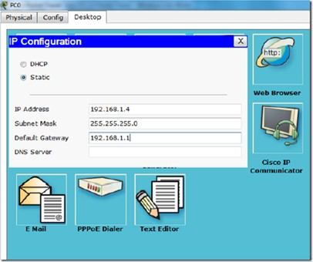

**PC1**

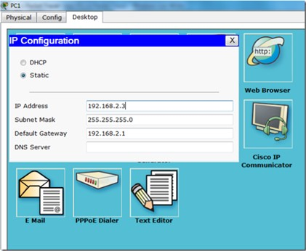

Now, our communication is enabled and we are able to communicate from PC0 to PC1 via Router. Click on the packet in the right panel on the packet tracer, then click on PC0 and then click on PC1. You will see the successful packet tracer (status is shown in the bottom right corner).

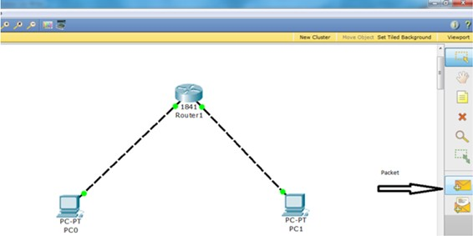

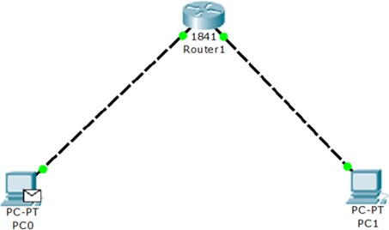

## Lab Exercises:

* 1. Set up a network with 4 switches and 8 PC’s and verify the connectivity between all the PC’s.
  2. Design and configure a network using 4 PC’s and a router. Configuration should be done using Command Line Interface (CLI).

# Lab No. 9: Implementation Basic Topologies using Packet Tracer

## Objectives

1. Implementation of Basic Topologies such as BUS, RING, MESH, STAR using packet tracer.

## What is Network Topology

Network topology refers to how various nodes, devices, and connections on your network are physically or logically arranged in relation to each other. Think of your network as a city, and the topology as the road map. Just as there are many ways to arrange and maintain a city—such as making sure the avenues and boulevards can facilitate passage between the parts of town getting the most traffic—there are several ways to arrange a network. Each has advantages and disadvantages and depending on the needs of your company, certain arrangements can give you a greater degree of connectivity and security.

There are two approaches to network topology: physical and logical. Physical network topology, as the name suggests, refers to the physical connections and interconnections between nodes and the network—the wires, cables, and so forth. Logical network topology is a little more abstract and strategic, referring to the conceptual understanding of how and why the network is arranged the way it is, and how data moves through it.

## Why Is Network Topology Important?

The layout of your network is important for several reasons. Above all, it plays an essential role in how and how well your network functions. Choosing the right topology for your company’s operational model can increase performance while making it easier to

locate faults, troubleshoot errors, and more effectively allocate resources across the network to ensure optimal network health. A streamlined and properly managed network topology can increase energy and data efficiency, which can in turn help to reduce operational and maintenance costs.

The design and structure of a network are usually shown and manipulated in a software-created network topology diagram. These diagrams are essential for a few reasons, but especially for how they can provide visual representations of both physical and logical layouts, allowing administrators to see the connections between devices when troubleshooting.

## Bus Topology

In local area network, it is a single network cable runs in the building or campus and all nodes are connected along with this communication line with two endpoints called the bus or backbone. In other words, it is a multipoint data communication circuit that is easily control data flow between the computers because this configuration allows all stations to receive every transmission over the network.

To build the topology and to test follow the given steps:

1. Select the end devices (Generic Laptop-PT) from the available devices.

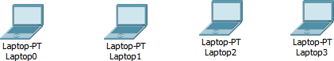

1. Choose switches (Generic)

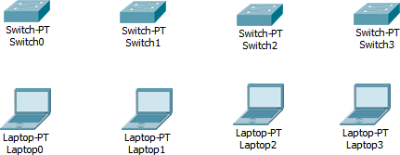

1. Choose connections between switches (Copper Cross-over)

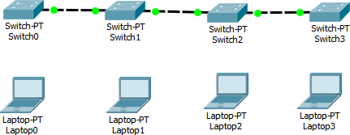

1. Choose connections between end devices (Copper Straight-Through)

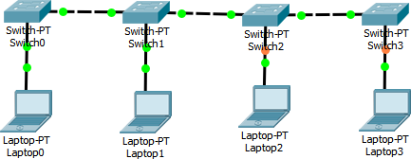

1. Configure end devices with class-c IP address.

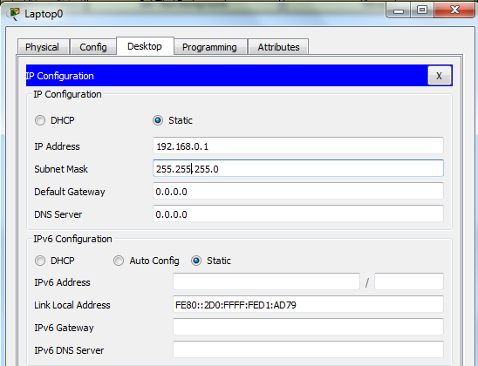

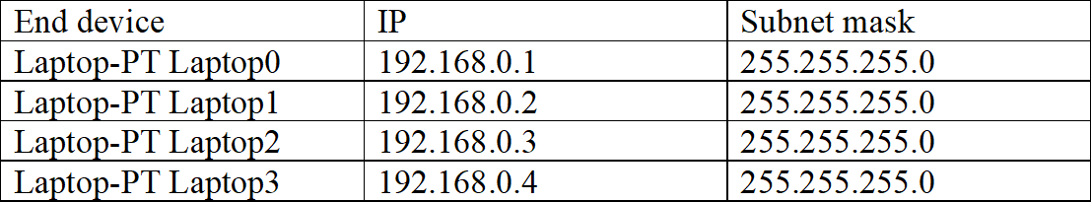

1. Send packet from source to destination.

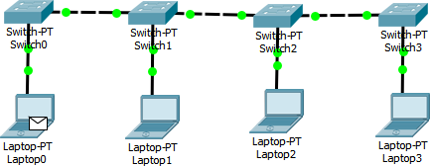

## Ring Topology

In ring topology each device is connected with the two devices on either side of it. There are two dedicated point to point links a device has with the devices on the either side of it. This structure forms a ring thus it is known as ring topology. If a device wants to send data to another device then it sends the data in one direction, each device in ring topology has a repeater, if the received data is intended for other device then repeater forwards this data until the intended device receives it.

To build the topology and to test follow the given steps:

1. Select the end devices (Generic Laptop-PT) from the available devices.

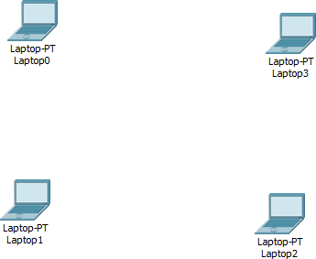

1. Choose switches (2950-24)

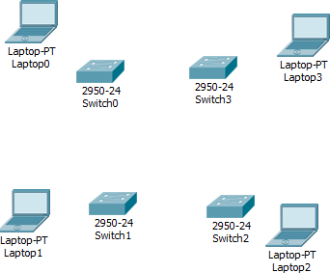

1. Choose connections between switches (Copper Cross-over)

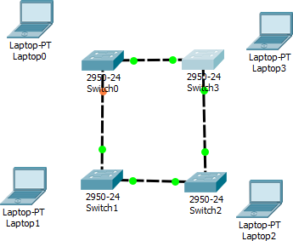

1. Choose connections between end devices (Copper Straight-Through)

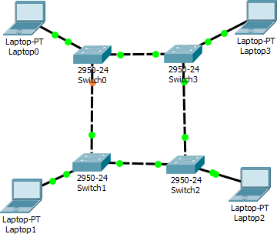

1. Assign IP configuration for the devices

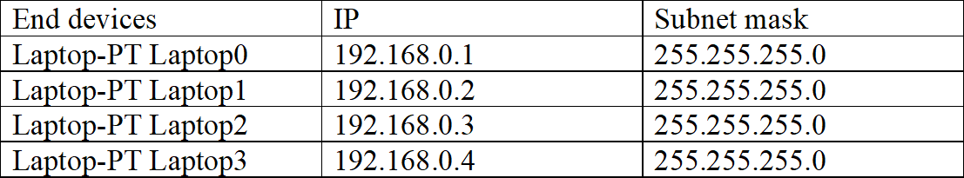



1. Send packet from source to destination.

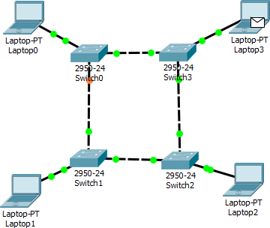

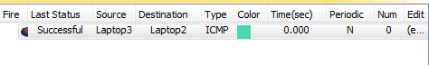

## Star Topology

In star topology, all the cables run from the computers to a central location where they are all connected by a device called a hub. It is a concentrated network, where the endpoints are directly reachable from a central location.

To build the topology and to test follow the given steps:

1. Select Switch



1. Select End Devices

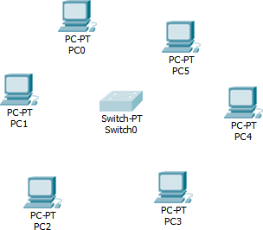

1. Since switch can be connected to four end devices, and here we have six end devices, so add two more modules.

Click on switch physical − *>* packet tracer switch off − *>* select PT-SWITCH-NM-

1CFE − *>* add two modules of it − *>* packet tracer switch on

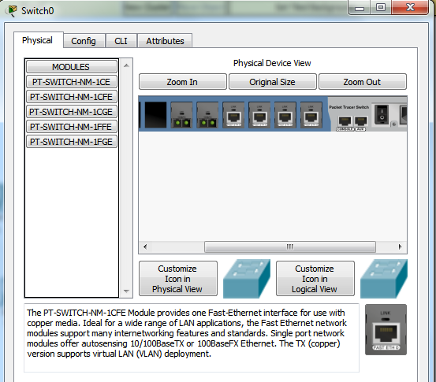

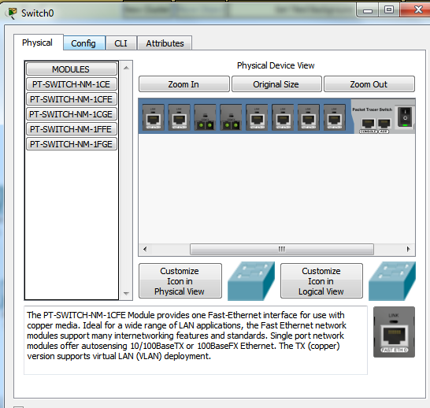

1. Choose connections between PCs and switch (Automatically choose Connection type).

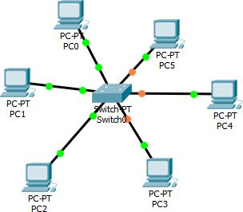

1. Configure the PC with IP address, subnet mask and default gateway

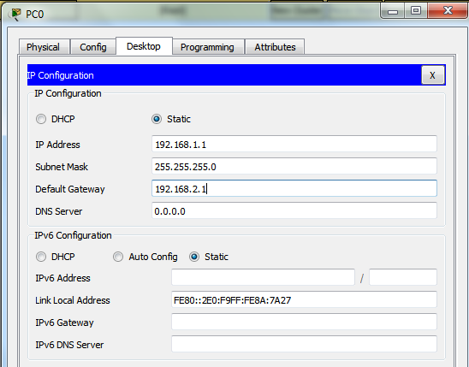

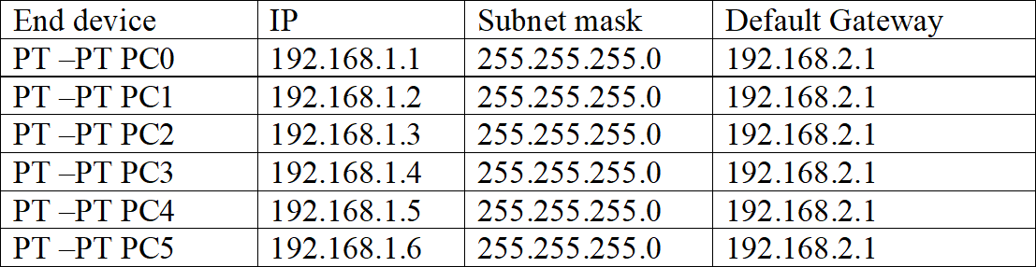

1. Send packet from source to destination.

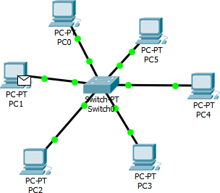



## Mesh Topology

In mesh topology every device has a dedicated point to point link to every other device. The term dedicated stand for link carries traffic only between two devices it connects. It is a well-connected topology; in this every node has a connection to every other node in the network. The cable requirements are high and it can include multiple topologies. Failure in one of the computers does not cause the network to break down, as they have alternative paths to other computers star topology, all the cables run from the computers to a central location. To build the topology and to test follow the given steps:

1. Select the switches

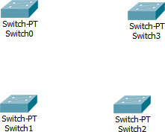

1. Select the end devices

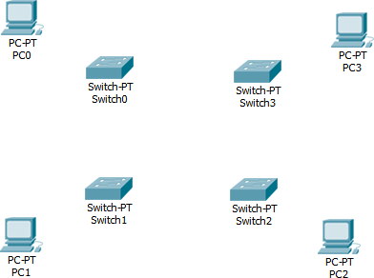

1. Connect the switches (Copper Cross Over)

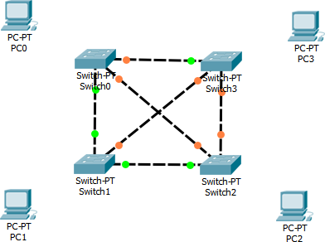

1. Connect end devices and switches (Copper Straight Through)

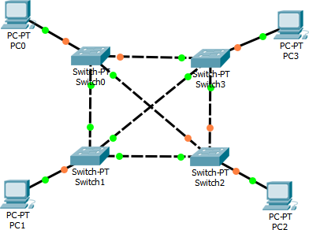

1. Configure end devices with IP address



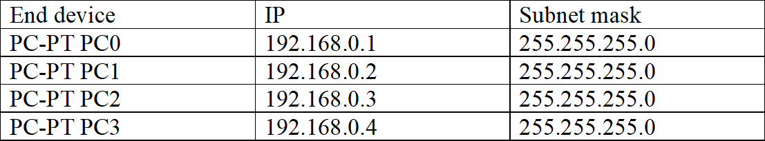

1. Send packets from source to destination

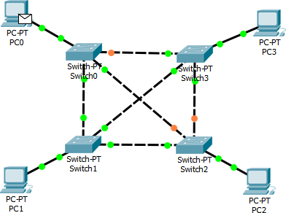

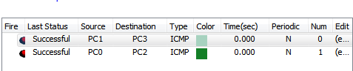

7.

## Lab Exercises

1. Design and implement Bus Topology with variations using Packet Tracer.
2. Design and implement Ring Topology with variations using Packet Tracer.
3. Design and implement Star Topology with variations using Packet Tracer.
4. Design and implement Mesh Topology with variations using Packet Tracer.

## Additional Exercise

1. Design and implement Hybrid Topology with variations using Packet Tracer.
2. Implement the Token Bus and Token Ring Protocols using Packet Tracer.

# Lab No. 10: Configuring Routing Protocols using Packet Tracer

## Objectives

1. To understand working principle of various routing protocols using packet tracer.
2. To make use of various routing protocols to route packets between the systems.

## RIP: Routing Information Protocol

Routing Information Protocol (RIP) is a standards-based, distance-vector, interior gateway protocol (IGP) used by routers to exchange routing information. RIP uses hop count to determine the best path between two locations. Hop count is the number of routers the packet must go through till it reaches the destination network. The maximum allowable number of hops a packet can traverse in an IP network implementing RIP is 15 hops. It has a maximum allowable hop count of 15 by default, meaning that 16 is deemed unreachable. RIP works well in small networks, but it’s inefficient on large networks with slow WAN links or on networks with a large number of routers installed. In a RIP network, each router broadcasts its entire RIP table to its neighboring routers every 30 seconds. When a router receives a neighbor’s RIP table, it uses the information provided to update its own routing table and then sends the updated table to its neighbors.

## Differences between RIPv1 or RIPv2

### RIPv1

* A classful protocol, broadcasts updates every 30 seconds, hold-down period 180 seconds. Hop count is metric (Maximum 15).
* RIP supports up to six equal-cost paths to a single destination, where all six paths

can be placed in the routing table and the router can load-balance across them. The default is actually four paths, but this can be increased up to a maximum of six. Remember that an equal-cost path is where the hop count value is the same. RIP will not load-balance across unequal-cost paths.

### RIPv2

* RIPv2 uses multicasts, version 1 use broadcasts, RIPv2 supports triggered updates—when a change occurs, a RIPv2 router will immediately propagate its routing information to its connected neighbors.
* RIPv2 is a classless protocol. RIPv2 supports variable-length subnet masking (VLSM) RIPv2 supports authentication. You can restrict what routers you want to participate in RIPv2. This is accomplished using a hashed password value.

## RIP Timers

RIP uses four different kinds of timers to regulate its performance:

1. Route update timer: Sets the interval (typically 30 seconds) between periodic routing updates in which the router sends a complete copy of its routing table out to all neighbors.
2. Route invalid timer: Determines the length of time that must elapse (180 seconds) before a router determines that a route has become invalid. It will come to this conclusion if it hasn’t heard any updates about a particular route for that period. When that happens, the router will send out updates to all its neighbors letting them know that the route is invalid.
3. Hold down timer: This sets the amount of time during which routing information is suppressed. Routes will enter into the hold down state when an update packet is received that indicated the route is unreachable. This continues either until an update

packet is received with a better metric or until the hold down timer expires. The default is 180 seconds.

1. Route flush timer: Sets the time between a route becoming invalid and its removal from the routing table (240 seconds). Before it’s removed from the table, the router notifies its neighbors of that route’s impending failure. The value of the route invalid timer must be less than that of the route flush timer. This gives the router enough time to tell its neighbors about the invalid route before the local routing table is updated.

## RIP Routing Configurations

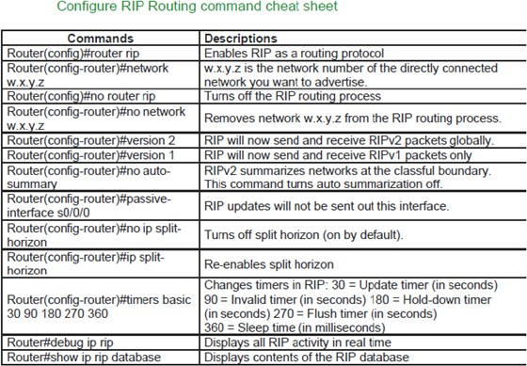

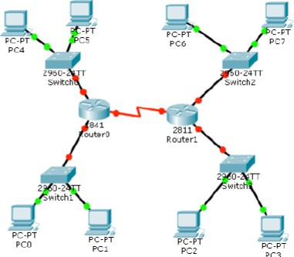

Assign ip address to PC. Select pc and double click on it. Select ip configurations from desktop tab and set ip address given as in table. To configure router double click on it and select CLI. To configure this topology use this step by step guide.

#### (1841Router0) Hostname R1:

To configure and enable rip routing on R1 follow these commands exactly.

Router *>*e n a b l e

R o u t e r # c o n f i g u r e t e r m i n a l

E n t e r c o n f i g u r a t i o n commands , one p e r l i n e . End w i t h CNTL/ Z .

R o u t e r ( c o n f i g )# hostname R1

R1 ( c o n f i g )# i n t e r f a c e f a s t e t h e r n e t 0 / 0

R1 ( c o n f i g −i f )# i p a d d r e s s 1 0 . 0 . 0 . 1 2 5 5 . 0 . 0 . 0 R1 ( c o n f i g −i f )# no shutdown

%LINK−5−CHANGED: I n t e r f a c e F a s t E t h e r n e t 0 / 0 , changed s t a t e t o up

%LINEPROTO−5−UPDOWN: Line p r o t o c o l on I n t e r f a c e F a s t E t h e r n e t 0 / 0 , changed s t a t e t o up

R1 ( c o n f i g −i f )# e x i t

R1 ( c o n f i g )# i n t e r f a c e f a s t e t h e r n e t 0 / 1

R1 ( c o n f i g −i f )# i p a d d r e s s 2 0 . 0 . 0 . 1 2 5 5 . 0 . 0 . 0 R1 ( c o n f i g −i f )# no shutdown

%LINK−5−CHANGED: I n t e r f a c e F a s t E t h e r n e t 0 / 1 , changed s t a t e t o up

%LINEPROTO−5−UPDOWN: Line p r o t o c o l on I n t e r f a c e F a s t E t h e r n e t 0 / 1 , changed s t a t e t o up

R1 ( c o n f i g −i f )# e x i t

R1 ( c o n f i g )# i n t e r f a c e s e r i a l 0 / 0 / 0

R1 ( c o n f i g −i f )# i p a d d r e s s 5 0 . 0 . 0 . 1 2 5 5 . 0 . 0 . 0 R1 ( c o n f i g −i f )# c l o c k r a t e 64000

R1 ( c o n f i g −i f )# bandwidth 64 R1 ( c o n f i g −i f )# no shutdown

%LINK−5−CHANGED: I n t e r f a c e S e r i a l 0 / 0 / 0 , changed s t a t e t o down

R1 ( c o n f i g −i f )# e x i t

R1 ( c o n f i g )# r o u t e r r i p

|  |  |
| --- | --- |
| R1 ( c o n f i g −r o u t e r )# network | 1 0 . 0 . 0 . 0 |
| R1 ( c o n f i g −r o u t e r )# network | 2 0 . 0 . 0 . 0 |
| R1 ( c o n f i g −r o u t e r )# network | 5 0 . 0 . 0 . 0 |
| R1 ( c o n f i g −r o u t e r )# e x i t  **(2811Router1) Hostname R2:** |  |

To configure and enable rip routing on R2 follow these commands exactly. Router *>*e n a b l e

R o u t e r # c o n f i g u r e t e r m i n a l

E n t e r c o n f i g u r a t i o n commands , one p e r l i n e . End w i t h CNTL/ Z .

R o u t e r ( c o n f i g )# hostname R2

R2 ( c o n f i g )# i n t e r f a c e f a s t e t h e r n e t 0 / 0

R2 ( c o n f i g −i f )# i p a d d r e s s 3 0 . 0 . 0 . 1 2 5 5 . 0 . 0 . 0 R2 ( c o n f i g −i f )# no shutdown

%LINK−5−CHANGED: I n t e r f a c e F a s t E t h e r n e t 0 / 0 , changed s t a t e t o up

%LINEPROTO−5−UPDOWN: Line p r o t o c o l on I n t e r f a c e F a s t E t h e r n e t 0 / 0 ,

changed s t a t e t o up R2 ( c o n f i g −i f )# e x i t

R2 ( c o n f i g )# i n t e r f a c e f a s t e t h e r n e t 0 / 1

R2 ( c o n f i g −i f )# i p a d d r e s s 4 0 . 0 . 0 . 1 2 5 5 . 0 . 0 . 0 R2 ( c o n f i g −i f )# no shutdown

%LINK−5−CHANGED: I n t e r f a c e F a s t E t h e r n e t 0 / 1 , changed s t a t e t o up

%LINEPROTO−5−UPDOWN: Line p r o t o c o l on I n t e r f a c e F a s t E t h e r n e t 0 / 1 ,

changed s t a t e t o up R2 ( c o n f i g −i f )# e x i t

R2 ( c o n f i g )# i n t e r f a c e s e r i a l 0 / 0 / 0

R2 ( c o n f i g −i f )# i p a d d r e s s 5 0 . 0 . 0 . 2 2 5 5 . 0 . 0 . 0 R2 ( c o n f i g −i f )# no shutdown

%LINK−5−CHANGED: I n t e r f a c e S e r i a l 0 / 0 / 0 , changed s t a t e t o up

R2 ( c o n f i g −i f )#

%LINEPROTO−5−UPDOWN: Line p r o t o c o l on I n t e r f a c e S e r i a l 0 / 0 / 0 ,

changed s t a t e t o up R2 ( c o n f i g −i f )# e x i t

R2 ( c o n f i g )# r o u t e r r i p

R2 ( c o n f i g −r o u t e r )# network 3 0 . 0 . 0 . 0 R2 ( c o n f i g −r o u t e r )# network 4 0 . 0 . 0 . 0 R2 ( c o n f i g −r o u t e r )# network 5 0 . 0 . 0 . 0 R2 ( c o n f i g −r o u t e r )# e x i t

To test rip routing do ping from pc0 to all pc and vice versa. If you get replay then you have successfully configured rip routing.

## Configure OSPF Routing Protocol

Configuration of OSPF routing protocol is easy as RIP Routing. The Open Shortest Path First (OSPF) is a routing protocol for wide area networks and enterprise network. OSPF is perhaps the most widely used interior gateway protocol (IGP) in large enterprise

networks. The most widely used exterior gateway protocol is the Border Gateway Protocol (BGP), the principal routing protocol between autonomous systems on the Internet.

#### Solved Example: Configure the following network using OSPF

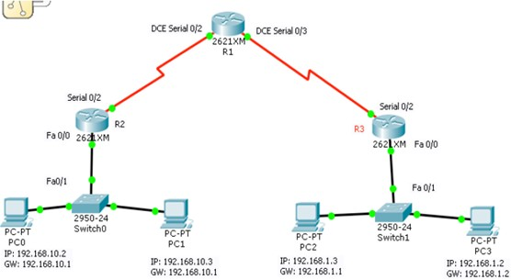

**Router 1**

R1*>*e n a b l e

R1# c o n f i g u r e t e r m i n a l

E n t e r c o n f i g u r a t i o n commands , one p e r l i n e . End wit h CNTL/ Z . R o u t e r ( c o n f i g )# hostname R1

R1 ( c o n f i g )# i n t e r f a c e s e r i a l 0 / 3

R1 ( c o n f i g −i f )# i p a d d r e s s 1 0 . 1 0 . 1 0 . 1 2 5 5 . 2 5 5 . 2 5 5 . 2 5 2 R1 ( c o n f i g −i f )# c l o c k r a t e 64000

R1 ( c o n f i g −i f )# no shutdown R1 ( c o n f i g −i f )# e x i t

R1 ( c o n f i g )#

R1 ( c o n f i g )# i n t e r f a c e s e r i a l 0 / 2

R1 ( c o n f i g −i f )# i p a d d r e s s 1 0 . 1 0 . 1 0 . 5 2 5 5 . 2 5 5 . 2 5 5 . 2 5 2 R1 ( c o n f i g −i f )# c l o c k r a t e 64000

R1 ( c o n f i g −i f )# no shutdown

#### Router 2

R o u t e r # e n a b l e

R o u t e r # c o n f i g u r e t e r m i n a l

E n t e r c o n f i g u r a t i o n commands , one p e r l i n e . End wit h CNTL/ Z . R o u t e r ( c o n f i g )# hostname R2

R2 ( c o n f i g )# i n t e r f a c e s e r i a l 0 / 2

R2 ( c o n f i g −i f )# i p a d d r e s s 1 0 . 1 0 . 1 0 . 6 2 5 5 . 2 5 5 . 2 5 5 . 2 5 2 R2 ( c o n f i g −i f )# no shutdown

R2 ( c o n f i g −i f )# e x i t

R2 ( c o n f i g )# i n t e r f a c e f a s t E t h e r n e t 0 / 0

R2 ( c o n f i g −i f )# i p a d d r e s s 1 9 2 . 1 6 8 . 1 0 . 1 2 5 5 . 2 5 5 . 2 5 5 . 0 R2 ( c o n f i g −i f )# no shutdown

#### Router 3

R o u t e r # e n a b l e

R o u t e r # c o n f i g u r e t e r m i n a l

E n t e r c o n f i g u r a t i o n commands , one p e r l i n e . End wit h CNTL/ Z . R o u t e r ( c o n f i g )# hostname R3

R3 ( c o n f i g )# i n t e r f a c e s e r i a l 0 / 2

R3 ( c o n f i g −i f )# i p a d d r e s s 1 0 . 1 0 . 1 0 . 2 2 5 5 . 2 5 5 . 2 5 5 . 2 5 2 R3 ( c o n f i g −i f )# no shutdown

R3 ( c o n f i g −i f )# e x i t

R3 ( c o n f i g )# i n t e r f a c e f a s t E t h e r n e t 0 / 0

R3 ( c o n f i g −i f )# i p a d d r e s s 1 9 2 . 1 6 8 . 1 . 1 2 5 5 . 2 5 5 . 2 5 5 . 0 R3 ( c o n f i g −i f )# no shutdown

#### Configure OSPF Routing Protocol

R1*>*e n a b l e

R1# c o n f i g u r e t e r m i n a l

E n t e r c o n f i g u r a t i o n commands , one p e r l i n e . End wit h CNTL/ Z . R1 ( c o n f i g )# r o u t e r o s p f 1

R1 ( c o n f i g −r o u t e r )# network 1 0 . 1 0 . 1 0 . 0 0 . 0 . 0 . 3 a r e a 0 R1 ( c o n f i g −r o u t e r )# network 1 0 . 1 0 . 1 0 . 4 0 . 0 . 0 . 3 a r e a 0 R1 ( c o n f i g −r o u t e r )#

The router OSPF command is enable OSPF routing on the router, and the 1 before OSFP is the process ID of the OSFP Protocol. You can set different process id from ”1-65535” for each router. The network command with network ID ”network 20.10.10.0” is the network identifier, and the ”0.0.0.3” is the wildcard mask of 20.10.10.0 network. Wildcard mask determine which interfaces to advertise, because OSPF advertise interfaces, not networks.

R2*>*e n a b l e

R2# c o n f i g u r e t e r m i n a l

E n t e r c o n f i g u r a t i o n commands , one p e r l i n e . End wit h CNTL/ Z . R2 ( c o n f i g )# r o u t e r o s p f 1

R2 ( c o n f i g −r o u t e r )# network 1 9 2 . 1 6 8 . 1 0 . 0 0 . 0 . 0 . 2 5 5 a r e a 0

R2 ( c o n f i g −r o u t e r )# network 1 0 . 1 0 . 1 0 . 4 0 . 0 . 0 . 3 a r e a 0 R3*>*e n a b l e

R3# c o n f i g u r e t e r m i n a l

E n t e r c o n f i g u r a t i o n commands , one p e r l i n e . End wit h CNTL/ Z . R3 ( c o n f i g )# r o u t e r o s p f 1

R3 ( c o n f i g −r o u t e r )# network 1 9 2 . 1 6 8 . 1 . 0 0 . 0 . 0 . 2 5 5 a r e a 0

R3 ( c o n f i g −r o u t e r )# network 1 0 . 1 0 . 1 0 . 0 0 . 0 . 0 . 3 a r e a 0

OSPF routing configuration has been finished successfully, now test your network whether they can ping with each other or not.

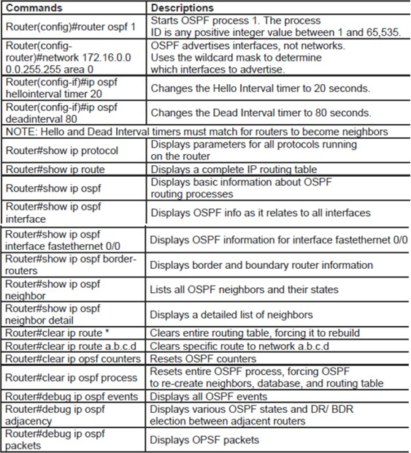

## Lab Exercises

1. Using RIP, configure the below network and verify the connectivity between PC0 and PC1.

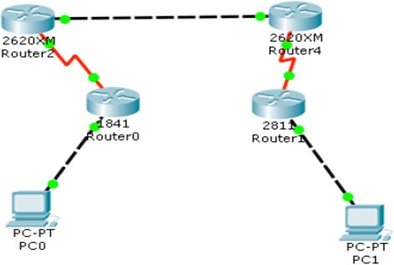

1. For the above given scenario, configure the network using OSPF and verify the connectivity between the PC’s.

# Lab No. 11: Configuring DHCP and NAT On A Multi-Function Device using Packet Tracer

## Objectives

1. To configure DHCP using packet tracer.
2. To examine NAT on a Multi-Function Device

## Network Address Translation (NAT)

The use of Network Address Translation (NAT) has been widespread for a number of years; this is because it is able to solve a number of problems with the same relatively simple configuration. At its most basic, NAT enables the ability to translate one set of addresses to another; this enables traffic coming from a specific host to appear as though it is coming from another and do it transparently.

### NAT Concepts

There are a number of different concepts that must be explained in order to really get a good understanding of how NAT operates, which ultimately makes the configuration of NAT increasingly simple. This section reviews these different concepts and begins with an understanding of how NAT can be used. Some of the main uses for NAT include:

* Translation of non-unique addresses into unique addresses when accessing the Internet: This is one of the most common uses of NAT today; almost every household that has a “router” to access the Internet is using NAT on this device to translate between internal private address and public Internet addresses.
* Translation of addresses when transitioning internal addresses from one address range into another (this is common when the organization of addresses within a company is being changed): This is often done when a company is transitioning

their IP addressing plan; common scenarios include when expanding (and the IP addressing plan was not built sufficiently when the initial addresses were assigned) and when a company is merging with another with potential overlapping addresses.

* When simple TCP load sharing is required across many IP hosts: This is very common, as many highly used servers are not really a single machine but a bank of several machines that utilize load balancing. In this scenario, commonly, a single public address is translated into one of several internal addresses in a round robin fashion. This is not a complete list of every possible way that NAT can be configured but simply a list of the most common ways that it is used in modern networks.

There are a couple of main concepts that also must be reviewed and understood before configuring NAT:

* Inside and Outside Addresses
* NAT types

1. Inside and Outside Addresses In typical NAT configurations, interfaces are placed into one of two categories (or locations): inside or outside. Inside indicates traffic that is coming from within the organizational network. Outside indicates traffic that is coming from an external network that is outside the organizational network. These different categories are then used to define different types of address depending on location of the address and how it is being “seen”. These different types include:
   1. inside local address: This is the inside address as it is seen and used within the organizational network.
   2. inside global address: This is the inside address as it is seen and used on the outside of the organizational network.
   3. outside local address: This is the outside address as it seen and used within the organizational network.
   4. outside global address: This is the outside address as it is seen and used on the outside of the organizational network.
2. NAT Types: Another important concept to be familiar with is the different types of NAT and how they are defined. On most networks there are three different types of NAT that are defined:
   1. Static Translation (Static NAT): This type of NAT is used when a single inside address needs to be translated to a single outside address or vice versa.
   2. Dynamic Address Translation (Dynamic NAT): This type of NAT is used when an inside address (or addresses) need to be translated to an outside pool of addresses or vice versa.
   3. Overloading Port Address Translation (PAT): This type of NAT is a variation on dynamic NAT. With dynamic NAT, there is always a one to one relationship between inside and outside addresses; if the outside address pool is ever exhausted, traffic from the next addresses requesting translation will be dropped. With overloading, instead of a one to one relationship, traffic is translated and given a specific outside port number to communicate with; in this situation, many internal hosts can be using the same outside address while utilizing different port numbers.

## Static NAT Configuration

There a few steps that are required when configuring static NAT; the number of the commands depends on whether there will be more than one static translation:

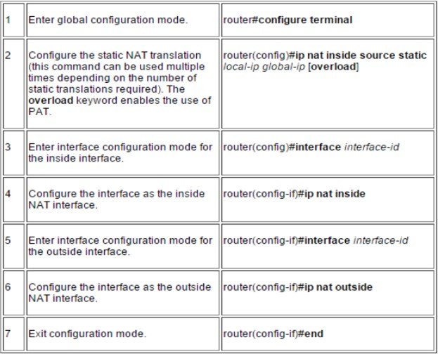

Using NAT we can hide real IP address, we can translate private IP address to public IP address and vice versa. As we all know in internet only public IP addresses are used and some IP in every class has been reserved for use in LOCAL AREA CONNECTION say LAN and these ranges of IP are known as Private IP Address. Private Addresses can only be used in LAN and it can’t be used in internet. But our PC with private address can communicate with PC or Machine having public IP address using NAT(Network Address Translation).

A public IP address is an IP address that can be accessed over the Internet. Like postal address used to deliver a postal mail to your home, a public IP address is the globally unique IP address assigned to a computing device. Private IP address on the other hand is used to assign computers within your private space without letting them directly expose to the Internet. For example, if you have multiple computers within your home you may want to use private IP addresses to address each computer within your home. In this scenario, your router get the public IP address, and each of the computers, tablets and smartphones connected to your router (via wired or wifi) get a private IP address from your router via DHCP protocol.

Internet Assigned Numbers Authority (IANA) is the organization responsible for registering IP address ranges to organizations and Internet Service Providers (ISPs). To

allow organizations to freely assign private IP addresses, the Network Information Center (InterNIC) has reserved certain address blocks for private use.

The following IP blocks are reserved for private IP addresses.

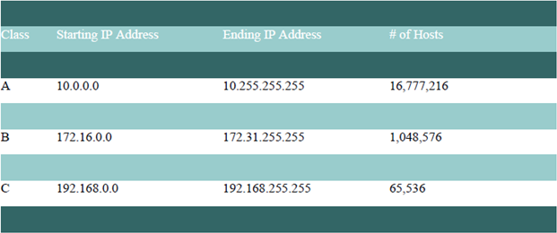

#### What is public IP address?

A public IP address is the address that is assigned to a computing device to allow direct access over the Internet. A web server, email server and any server device directly accessible from the Internet are candidate for a public IP address. A public IP address is globally unique, and can only be assigned to an unique device.

#### What is private IP address?

A private IP address is the address space allocated by InterNIC to allow organizations to create their own private network. There are three IP blocks (1 class A, 1 class B and 1 class C) reserved for a private use. The computers, tablets and smartphones sitting behind your home, and the personal computers within an organizations are usually assigned private IP addresses. A network printer residing in your home is assigned a private address so that only your family can print to your local printer.

When a computer is assigned a private IP address, the local devices sees this computer via it’s private IP address. However, the devices residing outside of your local network cannot directly communicate via the private IP address, but uses your router’s public IP address to communicate. To allow direct access to a local device which is assigned a private IP address, a Network Address Translator (NAT) should be used.

## How to configure NTP Server and NTP Client on cisco Router

Whenever we talks about cisco routers and how to set clock or accurate time on routers it becomes so important because a variety of services depend on it. We need to monitor our routers and secure our routers through server configuration. We use to configure syslog server for monitoring routers log and incident happening over routers. The logging service shows each log entry with the date and time and all details which are directly or indirectly related to NTP Server. It becomes very critical if you’re trying to track a specific incident or troubleshoot a problem.

Cisco routers have two types of clocks :

1. A battery-powered hardware clock, referenced as the ‘calendar’ in the IOS CLI, and
2. A software clock, referenced as the ‘clock’ in the IOS CLI.

The software clock is the primary source for time data and runs from the moment the system is up and running. The software clock can be updated from a number of sources.

## Configure DHCP on a Router

DHCP stands for Dynamic Host Configuration Protocol, as the name indicates it dynamically controls the hosts. DHCP is very common in home networks and in most enterprise networks. DHCP (Dynamic Host Configuration Protocol) is a networking protocol that permits network administrators centrally manage and automate the assignment of network parameters to a client device like PCs or Laptops.

1. DHCPDISCOVER: Server Discovery – Broadcast

In server discovery process, when a computer or other networked device connects to a DHCP network, it starts trying to discover whether there is any DHCP server

available in the network by sending broadcast to 255.255.255.255 destination address. This is called DHCPDISCOVER.

1. DHCPOFFER: IP Lease Offer – Unicast

After the DHCP server accepts the DHCPDISCOVER message, it replies with a DHCPOFFER message. This could be Unicast to the MAC address of the client and those packet includes an IPv4 address lease among the pool of IPs, Subnet mask, Gateway, DNS, lease duration.

1. DHCPREQUEST: IP request – Broadcast

Clients take the first offer received from DHCP server by broadcasting a DHCP Request packet called DHCPREQUEST. This message allowing the server to know that the client supposed to use the address offered by the server.

1. DHCPACK: IP lease acknowledgment – Unicast

The server directs an acknowledgment (DHCPACK) message in unicast, confirming that acceptance of the allotted IP for a specified period of time. It also used to renew the lease time.

## Solved Example:

1. Configure DHCP on routers for the given topology

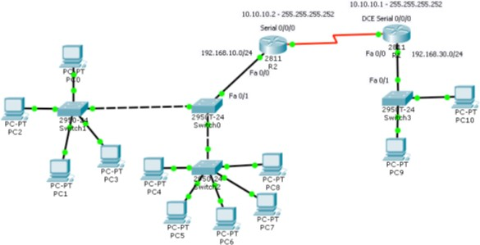

1. Configure the Router 1

Router *>*e n a b l e

R o u t e r # c o n f i g u r e t e r m i n a l

E n t e r c o n f i g u r a t i o n commands , one p e r l i n e . End wit h CNTL/ Z . R o u t e r ( c o n f i g )# hostname R1

R1 ( c o n f i g )# i n t e r f a c e s e r i a l 0 / 0 / 0

R1 ( c o n f i g −i f )# i p a d d r e s s 1 0 . 1 0 . 1 0 . 1 2 5 5 . 2 5 5 . 2 5 5 . 2 5 2 R1 ( c o n f i g −i f )# no shutdown

R1 ( c o n f i g −i f )# c l o c k r a t e 64000 R1 ( c o n f i g −i f )#

1. Configure the Router 2 Router *>*e n a b l e

R o u t e r # c o n f i g u r e t e r m i n a l

E n t e r c o n f i g u r a t i o n commands , one p e r l i n e . End wit h CNTL/ Z . R o u t e r ( c o n f i g )# hostname R2

R2 ( c o n f i g )# i n t e r f a c e s e r i a l 0 / 0 / 0

R2 ( c o n f i g −i f )# i p a d d r e s s 1 0 . 1 0 . 1 0 . 2 2 5 5 . 2 5 5 . 2 5 5 . 2 5 2 R2 ( c o n f i g −i f )# no shutdown

R2 ( c o n f i g −i f )#

R2 ( c o n f i g )# i n t e r f a c e f a s t E t h e r n e t 0 / 0

R2 ( c o n f i g −i f )# i p a d d r e s s 1 9 2 . 1 6 8 . 1 0 . 1 2 5 5 . 2 5 5 . 2 5 5 . 0 R2 ( c o n f i g −i f )# no shutdown

1. Lets config Router 2 as DHCP Server and set the clients to get there IP addresses from DHCP Server.

In the R2 while you are in the config mode, type the command ’ip dhcp excluded- address 192.168.10.1 192.168.10.20’ and then press enter. This command ’ip dhcp excluded-address’ will create an exclusive range of IP addresses which reserved for Network Servers and DHCP Server will not assign theme to clients.

The ’ip dhcp pool’ command create a pool for a network. You can create many pools on a router for all Local area network that connected to the router.

R2*>*e n a b l e

R2# c o n f i g u r e t e r m i n a l

E n t e r c o n f i g u r a t i o n commands , one p e r l i n e . End wit h CNTL/ Z . R2 ( c o n f i g )# i p dhcp excluded −a d d r e s s 1 9 2 . 1 6 8 . 1 0 . 1 1 9 2 . 1 6 8 . 1 0 . 2 0 R2 ( c o n f i g )# i p dhcp p oo l mynetwork ( you can g i v e any name )

R2 ( dhcp−c o n f i g )#

R2 ( dhcp−c o n f i g )# network 1 9 2 . 1 6 8 . 1 0 . 0 2 5 5 . 2 5 5 . 2 5 5 . 0 R2 ( dhcp−c o n f i g )# d e f a u l t −r o u t e r 1 9 2 . 1 6 8 . 1 0 . 1

R2 ( dhcp−c o n f i g )# dns−s e r v e r 1 9 2 . 1 6 8 . 1 0 . 1 0 0 R2 ( dhcp−c o n f i g )#

1. Now go to client setting and set the IP Configuration to DHCP and see the client get new IP address from DHCP Server.

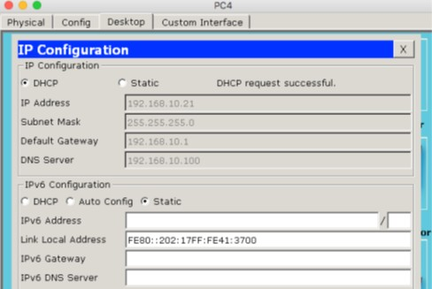

1. DHCP Options on Cisco Router: Remember some DHCP options when you need to provide IP addresses from a DCHP server to clients that are outside of your network or are not in the same Local Area Network. You must use the ’ip helper-address’ to forward the DHCP client requests to remote host.

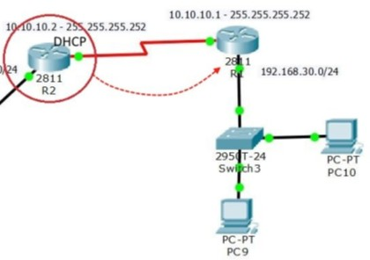

Configure the R1 to relay the DHCP client request. It will not work without routing. So configure Routers with static or dynamic routing. Here I’m testing with RIP.

R1*>*e n a b l e

R1# c o n f i g u r e t e r m i n a l

E n t e r c o n f i g u r a t i o n commands , one p e r l i n e . End wit h CNTL/ Z . R1 ( c o n f i g )# i n t e r f a c e f a s t E t h e r n e t 0 / 0

R1 ( c o n f i g −i f )# i p h e l p e r −a d d r e s s 1 0 . 1 0 . 1 0 . 2

R1 ( c o n f i g −i f )# e x i t

R1 ( c o n f i g )# r o u t e r r i p

R1 ( c o n f i g −r o u t e r )# network 1 0 . 1 0 . 1 0 . 0 R1 ( c o n f i g −r o u t e r )# network 1 9 2 . 1 6 8 . 3 0 . 0 R1 ( c o n f i g −r o u t e r )# e x i t

1. Go to the client IP configuration setting and see the forwarded request by DHCP Server.

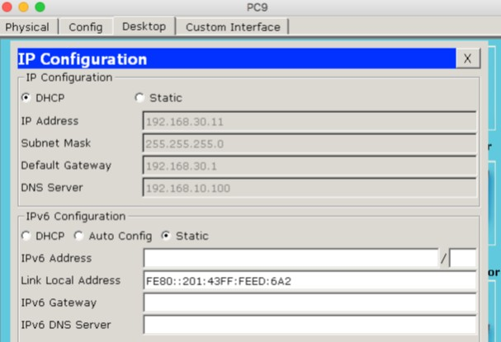

## Lab Exercises

1. Configure static NAT for the below given scenario. Also ping a private IP address given and mention your inference.

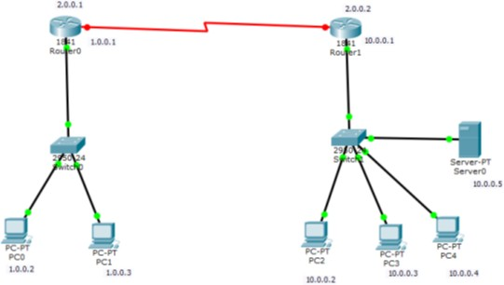

1. Perform NTP client-server configuration for the below given topology



1. Configure DHCP for the following topology.

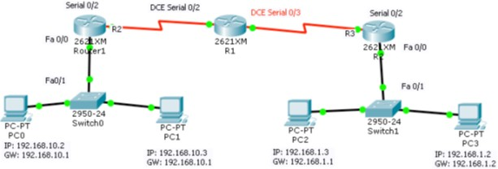

# Lab No. 12: Wireless Topology and VOIP using Packet Tracer

## Objectives

1. To create and configure wireless network using packet tracer
2. To configure VOIP

## Introduction

Let us create wireless topology on packet tracer.

For this go to the wireless devices and select wireless router, choose some PCs and provide them with wireless module so that they can communicate through router wirelessly.

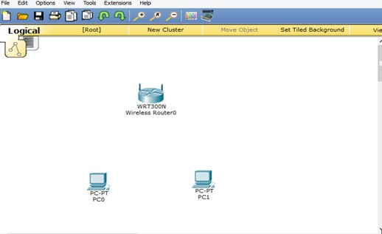

For providing wireless module, go to the PC physical mode Go to PC, and remove wired LAN and install WMP300N Module.

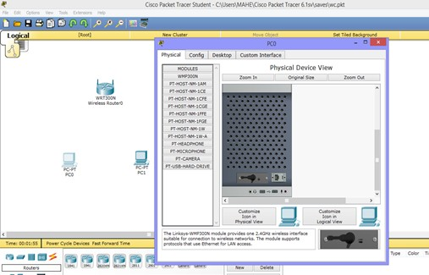

Repeat the procedure for PC1 Now devices are connected .

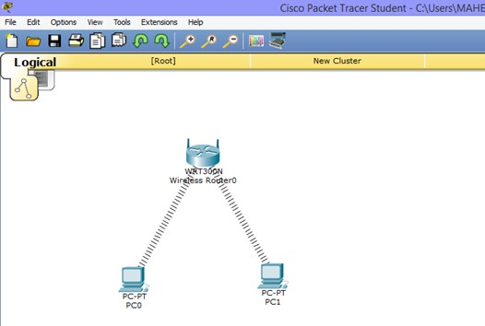

Set the IP address for the router.

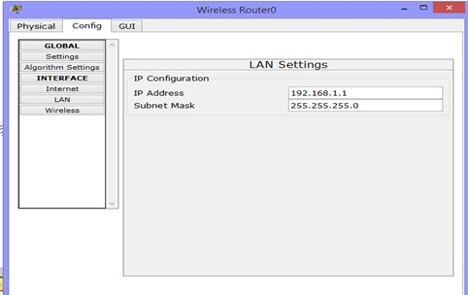

As this wireless router provides us with the DHCP service, so we can obtain IP automatically by using this service for our PCs.

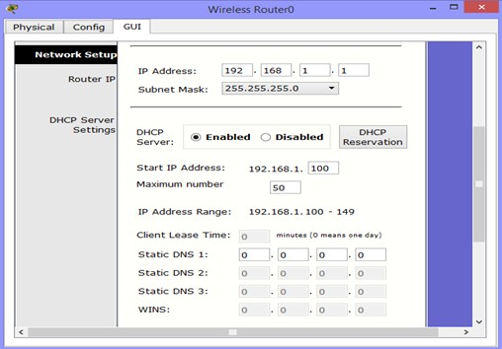

This enables the devices to communicate.

Now, let us apply authentication to our wireless router. For that, go to Config tab, click on Wireless. Provide it with the information (SSID and Passkey) as below.

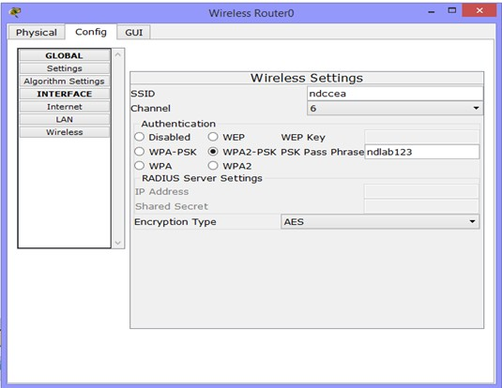

Go to PC desktop mode, Click on PC Wireless.

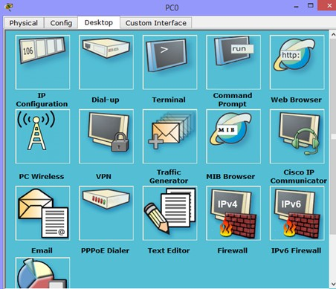

Go to PC desktop mode, Click on PC Wireless.

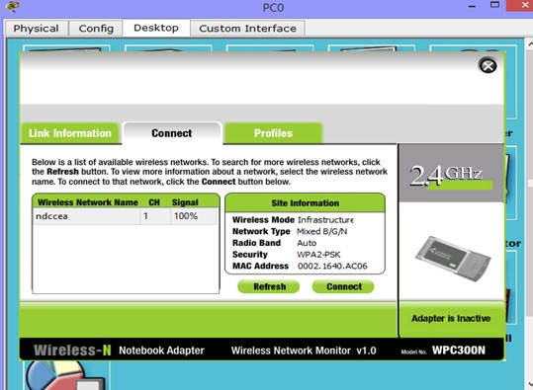

Go to the connect tab and click refresh.

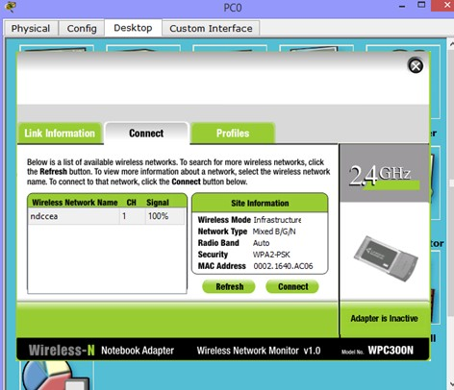

Now click on connect button and give the passkey you have set in the router.

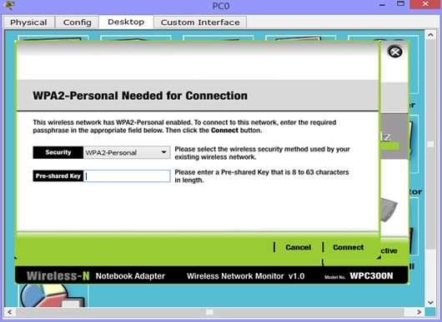

Now you can see that the PC has been connected to the router, you can also check the signal strength and quality by clicking on Link Information.

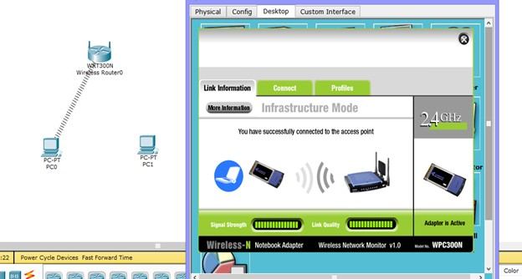

Repeat the procedure for PC2.

## VOIP(Voice Over IP)

VOIP is an acronym for Voice Over Internet Protocol, or in more common terms phone service over the Internet.

. If you have a reasonable quality Internet connection you can get phone service delivered through your Internet connection instead of from your local phone company. Some people use VOIP in addition to their traditional phone service, since VOIP service providers usually offer lower rates than traditional phone companies, but sometimes doesn’t offer 911 service, phone directory listings, 411 service, or other common phone services. While many VoIP providers offer these services, consistent industry-wide means of offering these are still developing.

**How does VOIP work?** A way is required to turn analog phone signals into digital signals that can be sent over the Internet.This function can either be included into the phone itself or in a separate box like an ATA.

VOIP Using an ATA

Ordinary Phone —- ATA —- Ethernet —- Router —- Internet —- VOIP Service Provider

VOIP using an IP Phone

IP Phone —– Ethernet —– Router —- Internet —- VOIP Service Provider

**VOIP connecting directly** It is also possible to bypass a VOIP Service Provider and directly connect to another VOIP user.

However, if the VOIP devices are behind NATrouters, there may be problems with this approach

. IP Phone —– Ethernet —– Router —- Internet —- Router —- Ethernet —- IP Phone Applications using VOIP

Traditional telephony applications, such as outbound call center applications and inbound IVR applications, normally can be run on VOIP

**Why use VOIP?** There are two major reasons to use VOIP

1. Lower Cost

In general phone service via VOIP costs less than equivalent service from traditional sources. This is largely a function of traditional phone services either being monopolies or government entities. There are also some cost savings due to using a single network to carry voice and data. This is especially true when users have existing under-utilized network capacity that they can use for VOIP without any additional costs.

. In the most extreme case, users see VOIP phone calls (even international) as FREE. While there is a cost for their Internet service, using VOIP over this service may not involve any extra charges, so the users view the calls as free. There are a number of services that have sprung up to facilitate this type of ”free” VOIP call. Examples are: FreeWorldDialup and Skype.

1. Increased Functionality

VOIP makes easy some things that are difficult to impossible with traditional phone networks. Incoming phone calls are automatically routed to your VOIP phone where ever you plug it into the network. Take your VOIP phone with you on a trip, and

anywhere you connect it to the Internet, you can receive your incoming calls.

Call center agents using VOIP phones can easily work from anywhere with a good Internet connection.

## Lab Exercises

1. In the below topology, we have three pc connected with Linksys Wireless routers.

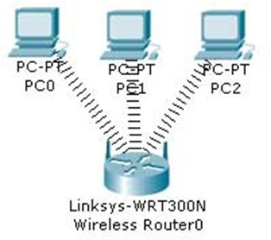

* 1. DHCP is configured and enabled on Wireless router (b) IP pool for DHCP is 192.168.0.100 to 192.168.0.150

1. PC are configured to receive IP from DHCP Server
2. No security is configured
3. Default SSID is configured to Default
4. Topology is working on infrastructure mode
5. Default user name and password is admin
6. IP of wireless is set to 192.168.0.1

Given the above information, perform the following tasks.

1. Configure Static IP on PC and Wireless Router
2. Change SSID to MotherNetwork
3. Change IP address of router to 10.0.0.1 and 10.0.0.2 of PC0 10.0.0.3 of PC1

10.0.0.4 of PC2

1. Secure your network by configuring WAP key on Router
2. Connect PC by using WAP key
3. Configure VOIP for the below given topology and call IP Phone1 from IP Phone0.

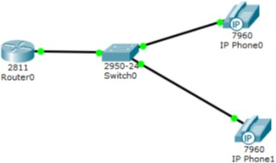

# References

1. Stevens R., Stephen A. R., Advanced Programming in the UNIX Environment (2e), Pearson Education, 2013.
2. Jesin A, Packet Tracer Network Simulator (1e), Packt Publishing, 2014.
3. Dr. M. O. Faruque Sarker, Sam Washington, Learning Python Network Programming (1e), Packt Publishing 2015